**CONTACT:** Susan Krysiak **For Immediate Release**

Director of Media Relations Aug. 15, 2025

609-224-6036

skrysiak@capemaymac.org

**Cape May MAC presents ‘For the Love of Hats’ Oct. 13 featuring 70 vintage and modern hats**

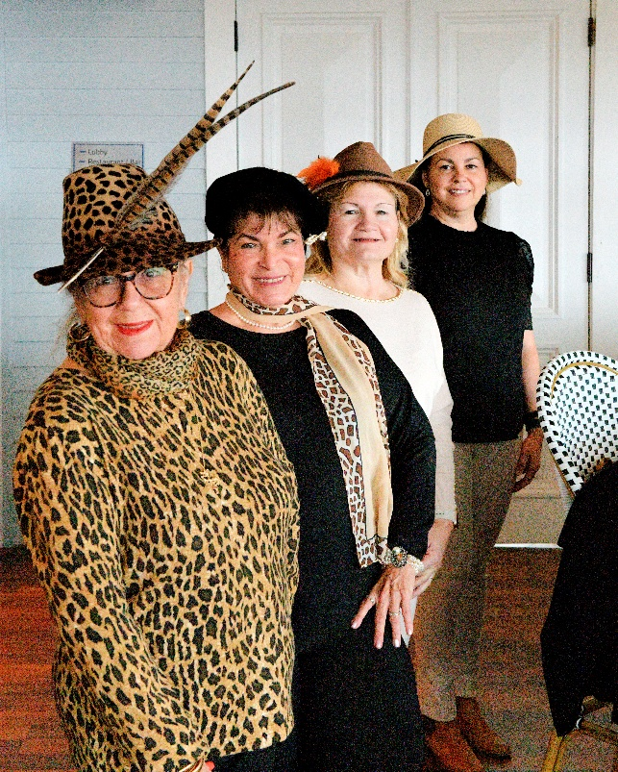

*(Photo courtesy of Cape May MAC)*

**(CAPE MAY, N.J.)** Learn about the history, etiquette and fashion of hats during a one-hour talk, show and three-course luncheon Monday, Oct. 13 at noon at the Inn of Cape May, presented by Lynne Anne Donchez, hat connoisseur and author of “For the Love of Hats.” The show is part of Victorian Weekend, Oct. 10-13, presented by Cape May MAC (Museums+Arts+Culture). Explore her extensive hat collection, featuring pillboxes, cloches, fascinators and more, with nearly 70 women’s and men’s hats from a range of eras. A Q&A session is included. Advance registration is required. Cape May MAC is a multifaceted not-for-profit organization committed to promoting the preservation, interpretation, and cultural enrichment of the Cape May region for its residents and visitors. For information about restaurants, accommodations and shopping, call the Chamber of Commerce of Greater Cape May at 609-884-5508.

###