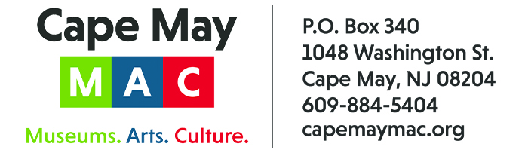

CONTACT: Susan Krysiak For Immediate Release
Director of Media Relations Aug. 15, 2025
609-224-6036
skrysiak@capemaymac.org

Cape May celebrates its Victorian era with tours and events during Victorian Weekend Oct. 10-13

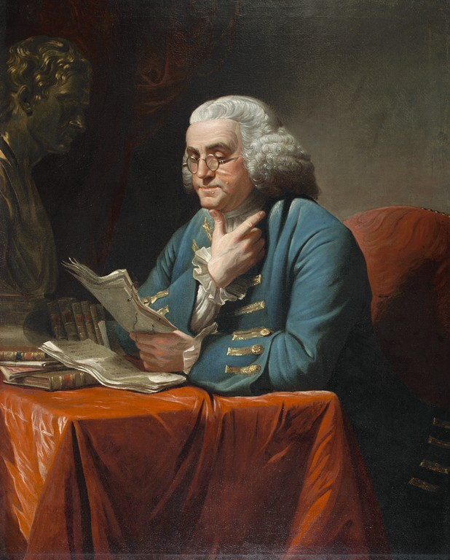
Benjamin Franklin, by David Martin. American Philosophical Society. Gift of Charles Willson Peale, 1785
CAPE MAY — Cape May’s 53rd annual Victorian Weekend, presented by Cape May MAC (Museums+Arts+Culture), celebrates the city’s famous Victorian architecture and history with a holiday weekend of house tours, walking tours, a crafts and collectibles show, murder mystery dinner, a show especially for hat lovers, trolley tours and more, from Friday, Oct. 10 through Monday, Oct. 13. Visit Victorian Cape May during this 53rd annual holiday weekend!
Don’t miss this year’s exciting vintage baseball game played with late 1800s rules. Vintage baseball treats will be available for sale and admission is free! Expand your knowledge of history with the 13th annual Lessons of History Distinguished Lecture Series, welcoming Professor of English Carla J. Mulford, Ph.D., Penn State University, and Director of the Library & Museum Michelle Craig McDonald, Ph.D. to present “Benjamin Franklin’s Revolutions.” Did you know that hats have their own history? Discover the world of vintage hats over a delicious lunch during Lynne Anne Donchez’s “For the Love of Hats.” Step inside Victorian houses and properties and explore on the Victorian Weekend Historic House Tour, take a walk along historic streets on the Victorian Weekend Architectural Walking Tour, and more, including the annual Victorian Weekend Crafts & Collectibles Show and watch the Wheelmen ride around, trolley tours, house tours, historic sites, and … so much more! Visit here for more information: https://capemaymac.org/experience/special-events/victorian-weekend/
Tour tickets may be purchased in advance by phone at 609-884-5404, online at capemaymac.org or in person by visiting Hill House Visitor Service Center or Carriage House Visitor Service Center, both at the Emlen Physick Estate, 1048 Washington St., or the Washington Street Mall Information Booth at Washington Street at Ocean Street. Cape May MAC is committed to making its programs accessible to as many individuals as possible.
Cape May MAC (Museums+Arts+Culture) is a multifaceted not-for-profit organization committed to promoting the preservation, interpretation, and cultural enrichment of the Cape May region for its residents and visitors. Cape May MAC operates and manages the 1879 Emlen Physick Estate, the 1859 Cape May Lighthouse and the 1942 World War II Lookout Tower, and is the leading organization to offer visitors tours, activities and events year-round in America’s National Historic Landmark City. Cape May MAC is the organization that saved the 1879 Emlen Physick Estate from demolition, helping secure the City of Cape May as an internationally recognized historic destination. For information about our year-round schedule of tours, festivals, and special events, call 609-884-5404 or visit capemaymac.org.

