CONTACT: Susan Krysiak For Immediate Release

Director of Media Relations Aug. 20, 2025

609-224-6036

skrysiak@capemaymac.org

**Cape May MAC presents ‘Benjamin Franklin’s Revolutions’ Sunday, Oct. 12 in Cape May**

13th Annual Lessons of History Distinguished Lecture Series welcomes speakers Carla J. Mulford, Ph.D. and Michelle Craig McDonald, Ph.D.

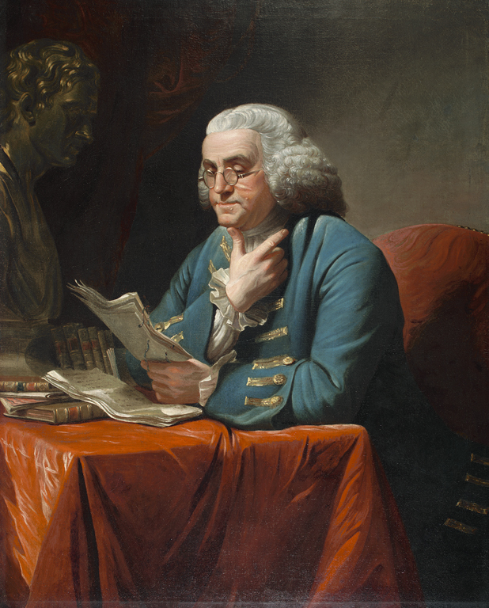

*Benjamin Franklin, by David Martin. American Philosophical Society. Gift of Charles Willson Peale, 1785*

**CAPE MAY, N.J. —** TheCape May MAC (Museums+Arts+Culture) annual Lessons of History Distinguished Lecture Series brings renowned speakers to Cape May to offer illuminating insights within their respective fields. In this 13th year, Penn State University Professor of English Carla J. Mulford, Ph.D., and American Philosophical Society Director of the Library & Museum Michelle Craig McDonald, Ph.D., present an in-depth, two-part look at founding father Benjamin Franklin, in “Benjamin Franklin’s Revolutions,” Sunday, Oct. 12 at 5 p.m. at Cape May Convention Hall, 714 Beach Ave.

Founder Benjamin Franklin’s accomplishments and talents were broad, deep, varied and crucially important to the fight for independence from Britain and the founding of a fledgling nation. He possessed extraordinary diplomatic finesse and had an insatiable curiosity, working well into his 80s. Franklin was the public face for independence, individual rights, and freedom from political tyranny. His private agony was his beloved son, governor of New Jersey, who remained steadfastly devoted to Britain. Through it all, Franklin’s wit and wisdom helped put a stamp on the new nation.

In this two-part presentation, Carla J. Mulford will talk about Benjamin Franklin and his relationship with his son during the crucial years of the American Revolution. She’ll then turn to the importance of Cape May’s port as a safe harbor for American ships as the Revolution began.

Michelle Craig McDonald will focus on another aspect of Franklin’s success in diplomacy — his ability to engage and amuse those around him. Stories of Franklin’s ability to meld politics with humor are legion, spanning his work in England and France, as well as in the colonies. Evidence appears not only in his professional papers, but also in his personal correspondence and deliberate efforts to craft his image.

Dr. Mulford, a scholar of British and American studies and founding president of the Society of Early Americanists, has taught at Penn State University for nearly 40 years. She has won two major Penn State teaching awards, in addition to receiving research fellowships for her scholarship from the American Council of Learned Societies, the National Endowment for the Humanities, the Andrew W. Mellon Foundation, the Alexander von Humboldt/Yale Macmillan Center History Network, and the New Jersey Historical Commission. In addition to publishing nearly two dozen essays and book chapters on Franklin, Dr. Mulford published “The Cambridge Companion to Benjamin Franklin” in 2009 and a well-received monograph, “Benjamin Franklin and the Ends of Empire” in 2015. A new book under the title “Benjamin Franklin’s Electrical Diplomacy” is currently being reviewed for publication. Continuing her work on Franklin’s diplomacy, she has undertaken a new book tentatively titled, “Benjamin Franklin, Mediterranean Piracy, and American Slavery.”

Dr. McDonald is the Librarian/Director of the Library & Museum at the American Philosophical Society, founded by Benjamin Franklin in 1743, and holder of over 80 percent of Franklin’s correspondence. She has worked for nearly three decades as an educator and administrator. McDonald is the author of “Coffee Nation: How One Commodity Transformed the Early United States,” published in 2025, and co-author of “Public Drinking in the Early Modern World: Voices from the Tavern,” which appeared in 2011. Her research focuses on early American trade and consumer behavior, and has received support from the Fulbright Foundation, National Endowment for the Humanities, Harvard Business School, McNeil Center for Early American Studies, Library Company of Philadelphia, the Winterthur Museum, Garden and Library, and the New Jersey Historical Commission. She has served on the governing boards of the Association of Caribbean Historians, the Society for Historians of the Early American Republic, and the Independent Research Library Association.

The 13th annual Lessons of History Distinguished Lecture Series lecture, “Benjamin Franklin’s Revolutions,” is Sunday, Oct. 12 at 5 p.m. at Cape May Convention Hall, 714 Beach Ave., Cape May, N.J. Admission is $40. Students and teachers with ID are $15. Tickets are limited. An American Sign Language (ASL) interpreter will be present. For tickets and information call 609-884-5404 or visit capemaymac.org.

###

Cape May MAC (Museums+Arts+Culture) is a multifaceted, not-for-profit organization committed to promoting the preservation, interpretation and cultural enrichment of the Cape May region for its residents and visitors. Cape May MAC membership is open to all. For information about Cape May MAC’s year-round schedule of tours, festivals and special events, visit [capemaymac.org](http://www.capemaymac.org).