

CONTACT: Susan Krysiak For Immediate Release
Director of Media Relations Oct. 17, 2025
609-224-6036
skrysiak@capemaymac.org

Walter Lindheimer Memorial Garden at Physick Estate honors memory of Dr. Physick’s gardener
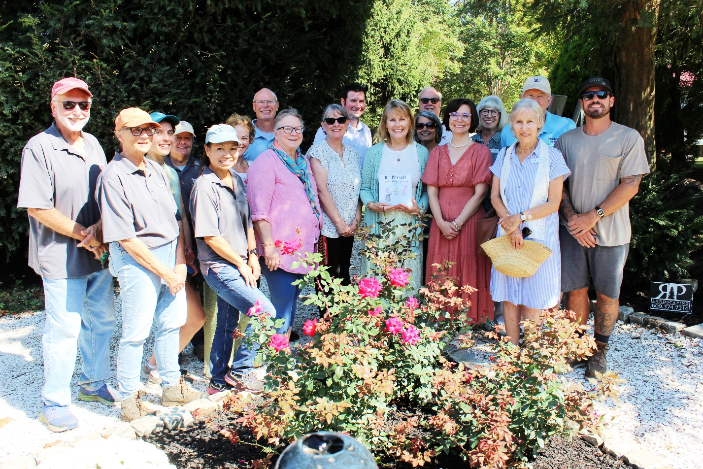
Photo by Susan Krysiak courtesy of Cape May MAC
Shown here, Patti Jo Kiraly and daughter Katie, with Cape May MAC staff, volunteers and gardeners, and City Councilperson Steve Bodnar, celebrate the completion of the Walter Lindheimer Memorial Garden at the Emlen Physick Estate Friday, Sept. 19.

CAPE MAY, N.J. – Cape May MAC (Museums+Arts+Culture) staff and volunteers celebrated the connection of a local family to the historic 1879 Emlen Physick Estate’s gardens by dedicating a memorial garden Friday, Sept. 19 in memory of Walter Lindheimer. Lindheimer was gardener for the 1879 Emlen Physick Estate employed by Dr. Emlen Physick in the late 19th century. Guests of honor were two of Walter Lindheimer’s descendants, Patti Jo Kiraly of Cape May, and her daughter Katie.
The Walter Lindheimer Memorial Garden is located near the driveway entrance from Washington Street into the estate next to the Cape May Tennis Club courts. A triangular patch of overgrown shrubbery near the estate’s clamshell walking path there is now a quiet spot of beauty. The garden was installed by Rich Pavese Landscaping with help from Cape May MAC staff and volunteer gardeners. It includes a fountain and two iron benches amid Double Knockout rosebushes, one Endless Summer hydrangea, purple coneflowers, hardy asters, spike speedwell (Veronica Snow Candles) and reed grasses.
Patti Jo reached out to Cape May MAC this year and made a generous donation to the organization in honor of Lindheimer, who is her great, great grandmother’s brother. That donation funded the creation of the new garden. Patti Jo has been a strong supporter of Cape May MAC in other ways, by donating week-long stays at her Cape May home for the annual online auction, for example.
Curator Ben Ridings, Director of Special Projects Danielle Dufner, Chief Outreach Officer Eliza Lotozo, Director & CEO Jody Alessandrine, and Master Gardener and volunteer Deb Yamashita, have been working together with Pavese to bring the plan to fruition, communicating with Patti Jo, her daughter Katie, and Walter’s great, great-granddaughter, Tricia.
The Emlen Physick Estate is an integral part of Cape May’s renaissance as a year-round tourist destination. It was designed by Victorian architect Frank Furness, built in 1879 and is frequently cited as the best example of Stick Style architecture in the country. Cape May MAC (Museums+Arts+Culture) (formerly the Mid-Atlantic Center for the Arts), saved the building from demolition in 1970, taking on the monumental task of restoring and serving as stewards for the mansion, opening it to the public. It has been voted “the prettiest building in New Jersey” by Angi.com based on TripAdvisor ratings. It is one of Cape May’s most important historic sites, and the city’s only Victorian House museum. Guided tours are offered daily that explain the architecture of the building and shares stories of the Physick family and their staff to give visitors an understanding of one family’s life during the Victorian era.
The garden will serve as a reminder of a Victorian gardener who played a role in the estate’s history over a century ago. It also offers visitors a beautiful place to stop, sit and enjoy the beauty of nature while they’re on the grounds.
“I see a lot of people come over to the garden and sit and enjoy its tranquility,” said Cape May MAC President Janet Coupland at Friday’s ceremony. “It’s absolutely beautiful.”
Patti Jo also donated family letters from Walter that include mention of Dr. Physick and their friendship, which Ridings has accepted into the museum’s collection. This year’s guided tour of the Physick House includes information gleaned from those letters.
“One of the things that charms me when I read (these letters) is the casual reference to his boss as “Dr. P.,” Patti Jo said at the dedication ceremony. “So, in our house we always call them Dr. P and Mrs. R (Mrs. Ralston, Dr. Physick’s mother).”
“I’m excited to have accepted these letters into our collection,” Ridings said. “Letters are original sources of history that often open a window to new discoveries. We are so fortunate and grateful to have received them from Patti Jo. They tell us more about Walter, and by extension about the life and times of the Physick family, their friends and staff, as well as about life in the Victorian era in general. Walter Lindheimer lived here on the estate since his family couldn’t spare the farm horse to take Walter back and forth to the Physick Estate daily. So, Walter stayed in the gardener’s house, a brick building situated now on the tennis club grounds. There’s more to tell and we’ve included it in this year’s guided tour of the museum.”
Kiraly’s family has been in Cape May since the 1860s when they settled in West Cape May. They built a house in Cape May on Windsor Avenue in 1896 that is still owned by the family.
“Cape May is such an integral part of our humanity and our homes and our families,” Patti Jo said Friday. “This is just another piece of the puzzle that we’ve been able to put back together, that keeps the link between us and Dr. P’s house. My grandfather Bob Cunningham was instrumental in the early days of MAC and he always spoke incredibly highly of his work here and the people he worked with. Tom Carroll was one of his best friends in Cape May, with my grandmother Emily. They were very involved in the arts here and in helping to put the (Physick) house together when it was finally able to be shown. It’s an honor for us to be here and be a part of this.”
The 2025 guided tour of the Physick House Museum is titled “The Art of Home,” and explores the rich artistry of Victorian life. Designed by architect Frank Furness, the home showcases Stick Style architecture with intricate moldings, custom furniture, and vibrant wallpapers. Beyond décor, the era’s artistic traditions shine through unexpected details like mourning jewelry made from hair and whimsical “rogue taxidermy” in parlor shades. Even functional elements, from pocket shutters to ceiling medallions, were crafted with elegance. Each room tells a story of beauty, memory, and creativity, making the Physick Estate a living masterpiece of 19th-century design and expression.
Cape May MAC (Museums+Arts+Culture) is a multifaceted not-for-profit organization committed to promoting the preservation, interpretation, and cultural enrichment of the Cape May region for its residents and visitors. For information about our year-round schedule of tours, festivals, and special events, call 609-884-5404 or visit capemaymac.org. Cape May MAC is committed to making its programs accessible to as many individuals as possible. If you require assistance, please call 609-884-5404 in advance so we may accommodate you. New Jersey Relay Center for TTY customers, please call 711 (800-852-7899).

