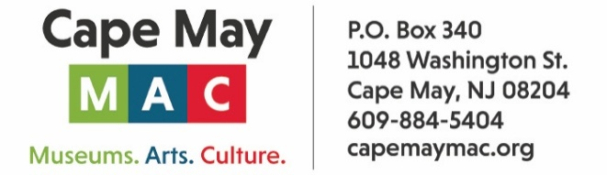

CONTACT: Susan Krysiak For Immediate Release
Director of Media Relations Oct. 21, 2025
609-224-6036
skrysiak@capemaymac.org

Classical Cape May 2025-26 season features free classical music concerts each month

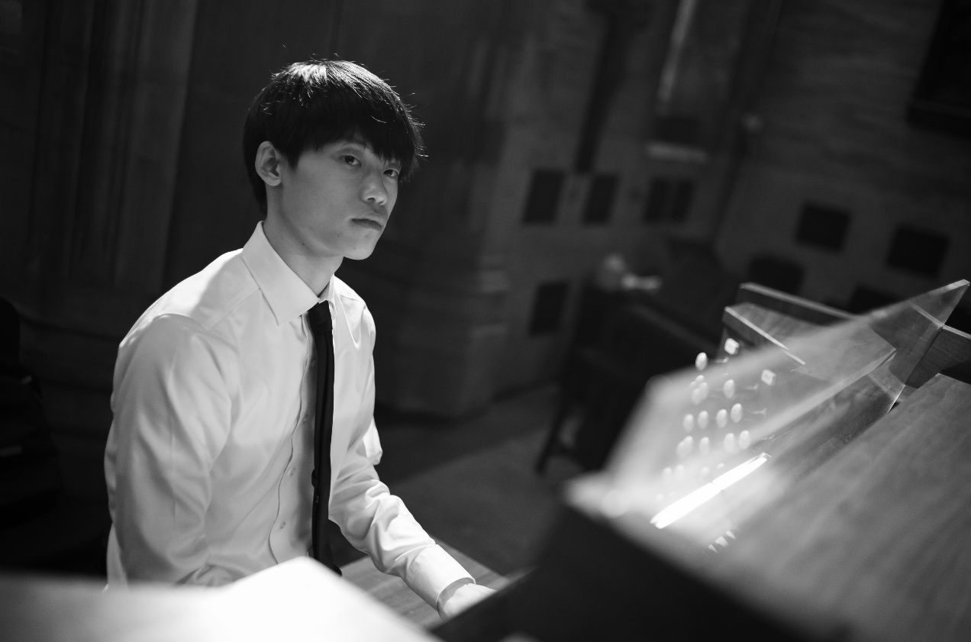
Provided
A rising young star on the organ, Eddie Zheng performs “Organ Masterworks” on Sunday, Nov. 2 as part of the Classical Cape May series.

CAPE MAY, N.J. — Classical Cape May, in partnership with the annual Cape May Music Festival presented by Cape May MAC (Museums+Arts+Culture) and supported in part by a grant from the New Jersey State Council on the Arts, announces a new season of concerts this fall through spring of 2026, expanding its series of free classical music concerts to a full seven months, with the first concert in the series this October.

Concerts are held at the Episcopal Church of the Advent, 612 Franklin St. (Franklin and Washington streets) Cape May, from 4 p.m. to 5 p.m. and admission is free. Goodwill offerings are graciously accepted and help support the cost of programming. Attendees are invited to a reception after each program to meet the artists.

Sunday, Nov. 2
Organ Masterworks
Eddie Zheng, organ
In November, we’re thrilled to present organist Eddie Zheng, one of the brightest rising stars in today’s classical music scene. With three degrees from The Juilliard School and an international performance career already spanning the world, Mr. Zheng brings dazzling technique and fresh insight to every program. His recital will showcase the expressive power and grandeur of the organ.

Sunday, Dec. 26
Christmas Hymn Sing-Along
A holiday gift from Classical Cape May, Episcopal Church of the Advent, and Cape May MAC
Join us on Dec. 26—Boxing Day—for a joyful celebration presented by Classical Cape May, Cape May MAC and the Episcopal Church of the Advent. Led by local musicians including organist Tom Crawford, this festive Christmas Hymn Sing invites all ages to come together in song and spirit. Bring the whole family and lift your voices in favorite carols and hymns. Start a new family tradition with us!

Sunday, Jan. 11
American Ethos
Carolyn Enger, piano
Acclaimed New Jersey pianist Carolyn Enger presents American Ethos, a powerful program that celebrates the rich diversity of American composers. Through selections by Leonard Bernstein, Florence Price, Ned Rorem, and others, Ms. Enger shines a light on often-overlooked voices who reflect the unique spirit and cultural mosaic of our nation. This recital invites us to listen deeply to the many threads that make up the American musical landscape.

Sunday, Feb. 8
Perfect Harmony
Christopher and Karen DiSanto, clarinets, Piang Liang, bassoon
Join us for a program of rich and colorful chamber music featuring clarinetists Christopher DiSanto and Karen DiSanto and bassoonist Ping Liang, all members of the Bay Atlantic Symphony. This talented trio brings warmth, virtuosity, and a deep musical connection to the stage. Their program will feature an engaging mix of repertoire including works by Mozart, Beethoven, Stravinsky and others.

Sunday, March 8
Let’s Hear from Your Directors
Brenda Leonard, cello, Robert Bullington, baritone, Noriko Schneiderman, piano
Classical Cape May co-directors Brenda Leonard and Robert Bullington are joined by pianist Noriko Schneiderman for an afternoon of chamber music. The program includes Sergei Prokofiev’s deeply expressive Cello Sonata and a selection of art songs, showcasing the creative spirit at the heart of Classical Cape May.

Sunday, April 12
Encore: Mostly Motets
Mostly Motets Chamber Choir
We close our season with a return performance by Mostly Motets, a chamber choir featuring singers from Pennsylvania and New Jersey. Known for their expressive blend and elegant interpretations, the group offers a program of vocal works spanning centuries and styles. Whether Renaissance polyphony or contemporary gems, Mostly Motets brings clarity, warmth, and precision to every performance—an intimate and inspiring finale to our season.

Classical Cape May is co-founded and co-directed by Brenda Leonard and Robert Bullington. The mission is to bring a variety of free classical performances to Cape May during the winter season, and to celebrate local and regional classical music talent. The series is open to all ages and interests, and donations are most welcome. classicalcapemay.com.

