

CONTACT: Susan Krysiak For Immediate Release
Director of Media Relations Oct. 23, 2025
609-224-6036
skrysiak@capemaymac.org

Cape May’s ‘An Old-fashioned Christmas Exhibit,’
Nov. 21-Jan. 4, delights the child in everyone

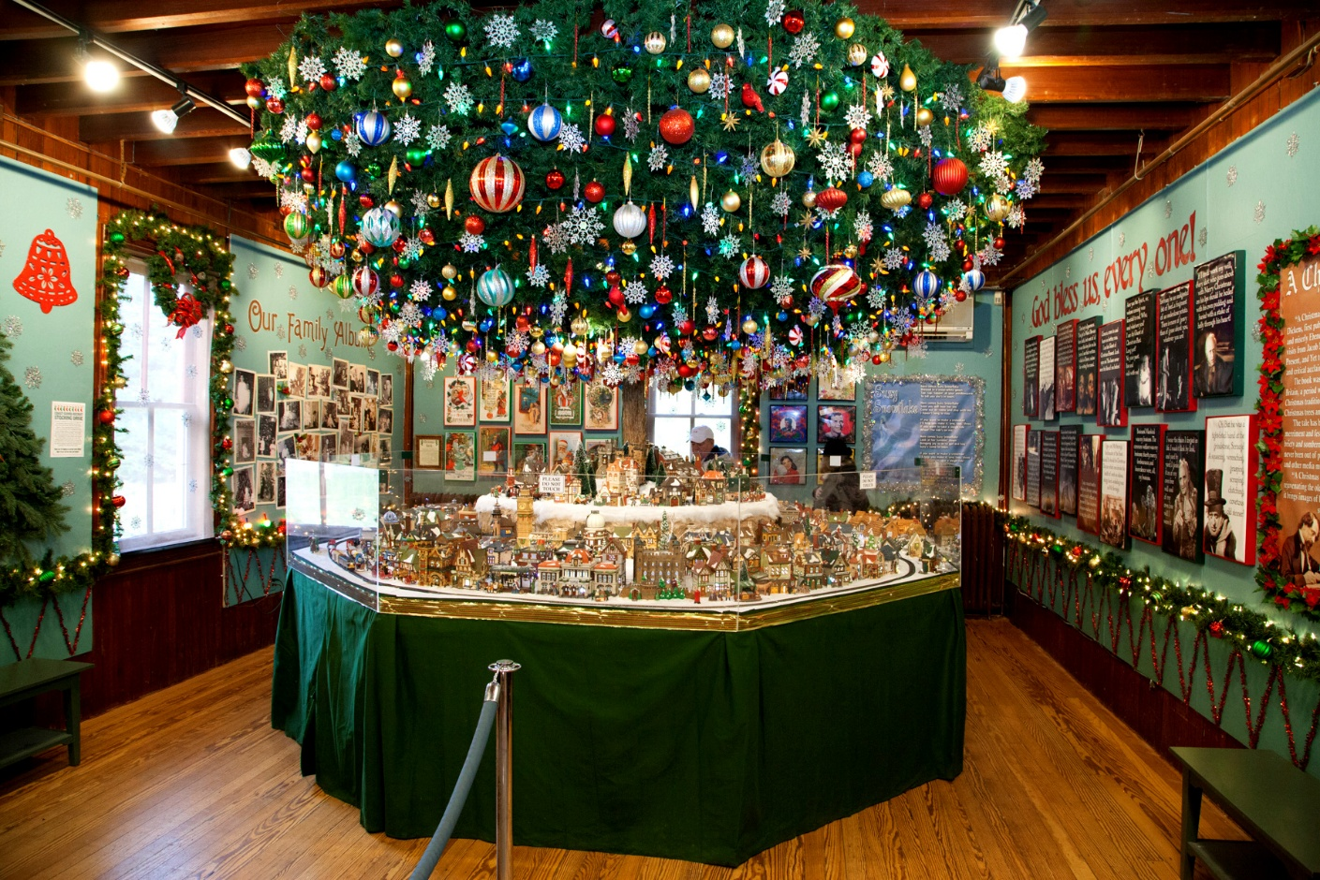

Pictured here (photo courtesy of MAC): Since 2011, thousands of Christmas holiday visitors to Cape May’s Emlen Physick Estate, 1048 Washington St., both young and old, have delighted in “An Old-Fashioned Christmas Exhibit: Holiday Traditions through the Years,” an extravagant exhibit that has come to be a Cape May holiday season tradition. Experience this exhibit celebrating holiday traditions complete with a giant Christmas tree, a Dept. 56 Dickens Village, model trains, nostalgic photos from Christmas past, toys and much more. In 2009, Cape May MAC (Museums+Arts+Culture) received a donation of an extensive Dept. 56 Dickens Village Collection from Ernie & Betsy Heegard. The collection has become the integral piece in this exhibit, featuring a variety of Dickens village pieces lit for the holiday. The exhibit is open daily Nov. 21 through Jan. 4, 2026 (except Thanksgiving and Christmas). Admission is free. Cape May MAC (Museums+Arts+Culture) is a multifaceted not-for-profit organization committed to promoting the preservation, interpretation, and cultural enrichment of the Cape May region for its residents and visitors. Membership is open to all. For information on tours, festivals and special events available year-round, call 609-884-5404 or visit capemaymac.org. For information about restaurants, accommodations and shopping, call the Chamber of Commerce of Greater Cape May at 609-884-5508 or visit capemaychamber.com.

###

