

CONTACT: Susan Krysiak For Immediate Release
Director of Media Relations Oct. 23, 2025
(609) 224-6036 or (609) 884-5404 Ext. 153
skrysiak@capemaymac.org

Cape May MAC’s 52nd Annual Christmas Candlelight House Tours are Dec. 6, 13 & 20

Visit historic homes, inns, museums, churches and hotels elaborately decorated for the holidays on this Christmas classic, the longest-running tour in Cape May

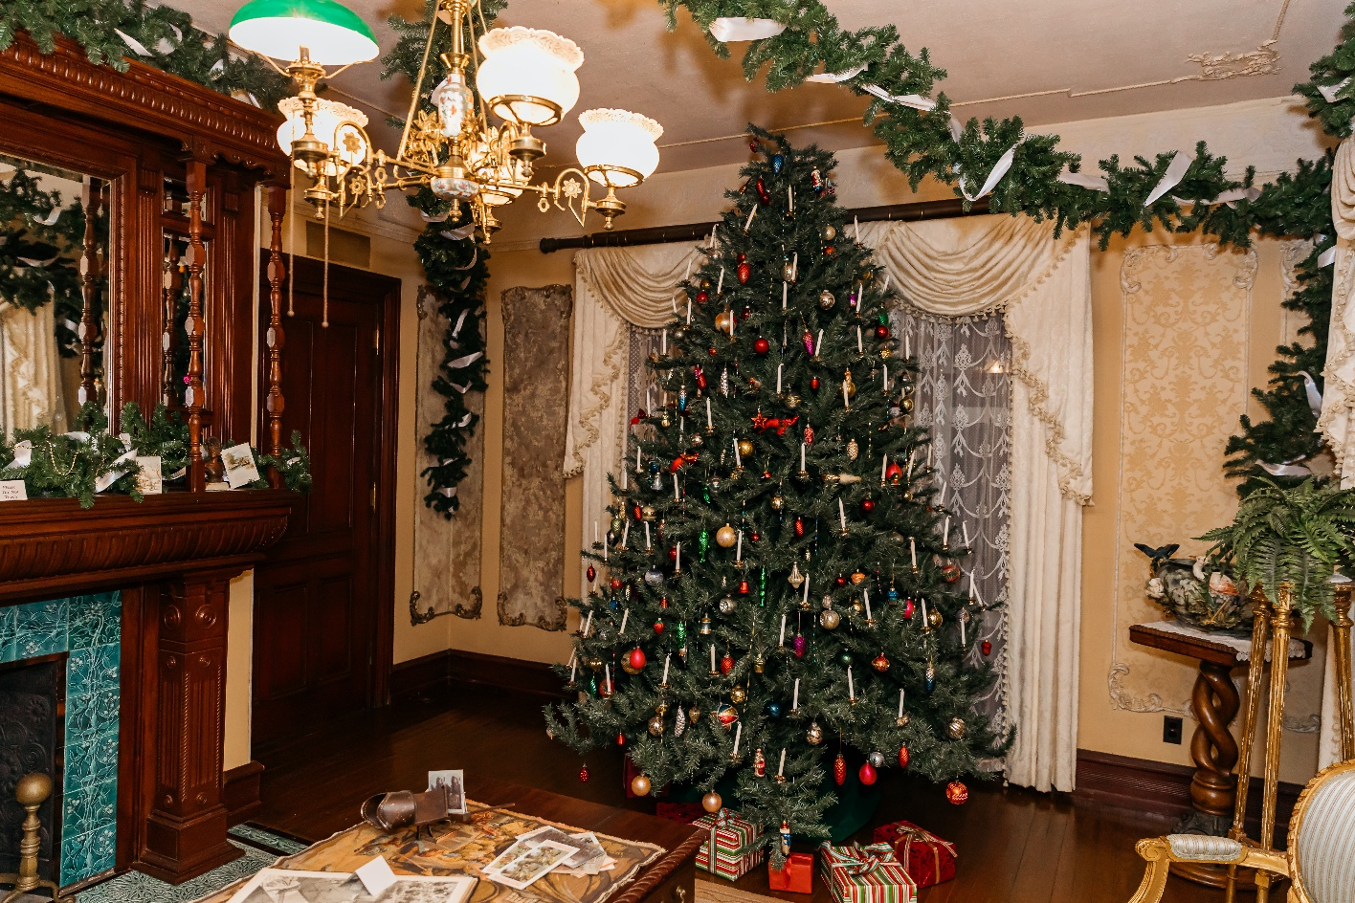
CAPE MAY — Come to Cape May, N.J. and enjoy the crisp night air and strolling carolers as you walk through the historic district and are welcomed inside historic homes, churches, museums and inns to see beautifully decorated interiors. Don’t miss this highlight of the holiday season in Cape May, the Christmas Candlelight House Tours, presented by Cape May MAC (Museums+Arts+Culture.)
A large selection of historic properties open their doors and welcome visitors to share the warmth and hospitality of the season during these popular, self-guided, walking tours. Strolling musicians entertain throughout the area on these nights. The three Christmas Candlelight House Tours of the 2025 season are Saturday, Dec. 6, 13 and 20, from 5:30 p.m. to 8:30 p.m.
Cape May MAC launched this evening walking tour in 1974 and ever since it has been a highlight of the holiday season in Victorian Cape May, America's only National Historic Landmark City. Stroll along gaslit streets and visit homes, inns, B&Bs, churches and hotels, most within walking distance of each other, to see lovely interiors decorated for the holidays. This self-guided tour, centered in a 3/4-square-mile area of the Historic District, is Cape May MAC’s largest annual fund-raiser.
Christmas Candlelight House Tours include admission to Cape May’s authentically decorated Victorian house museum, the Emlen Physick Estate at 1048 Washington St., and the exhibit “An Old-Fashioned Christmas: Holiday Traditions through the Years” in the Carroll Gallery in the Carriage House located on the grounds of the Physick Estate. The exhibit’s main attraction is a display featuring a Dept. 56 Dickens Village, model trains and vintage Christmas memorabilia, all beneath the boughs of a giant Christmas tree. While there, letters to Santa can be deposited for mailing to Santa’s workshop at the North Pole.
Ticket purchasers obtain a map and wristband the day before or day of the tour at the 1879 Emlen Physick Estate, 1048 Washington St. Advance purchase is highly recommended as tickets sometimes sell out. As in 2024, an express shuttle will operate between the Physick Estate and the one or two farthest points. Most properties are clustered within a 20-minute walk in the Historic District with some just a few minutes from each other, and that makes walking the most efficient way to see the most properties with the least time spent waiting. Wear your most comfortable walking shoes, dress in layers, bring a flashlight, and feel the holiday merriment as you stroll and explore participating properties on foot in Cape May's Historic District.
Admission to the Christmas Candlelight House Tour is $45 for adults and $30 for children (ages 3 to 12). A list of participating properties is available at capemaymac.org. The tour is limited; it is strongly recommended that tickets be purchased in advance online at capemaymac.org or by calling 609-884-5404. Any remaining tickets on the day of the tour may be purchased at the Washington Street Mall Information Booth, Washington and Ocean Streets. Properties on the tour are subject to change. Updates can be found at capemaymac.org. For more information call 609-884-5404.

