

CONTACT: Susan Krysiak For Immediate Release
Director of Media Relations Oct. 23, 2025
609-224-6036
skrysiak@capemaymac.org

Children’s tours spark joy and wonder in all during Christmas in Cape May Nov. 21-Jan. 4

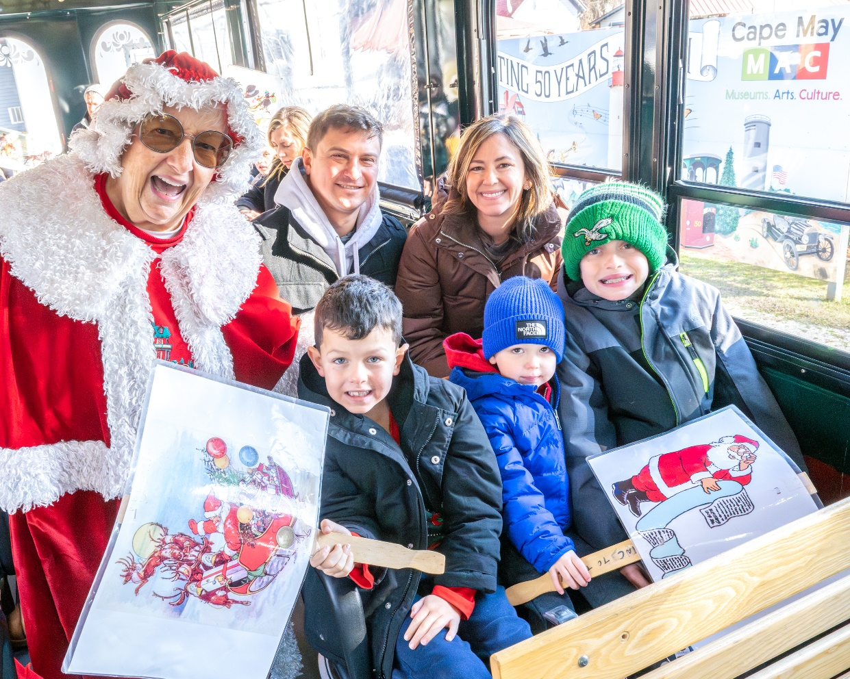

Photo courtesy of Cape May MAC
Shown here, Mrs. Claus leads a Santa’s Trolley Ride in Cape May that also includes An Old-fashioned Christmas Exhibit, and a greeting from Santa, himself.

CAPE MAY – Christmas is a magical time of the year, capturing the imagination of children and fueling the excitement of possibilities. Cape May MAC (Museums+Arts+Culture) offers a bounty of tours and events in Cape May for children and families during the holiday season, Nov. 21-Jan. 4, 2026.
New! If you’ve never gone Christmas caroling, here is your opportunity. The Caroling in Victorian Cape May Walking Tour takes you on a festive caroling tour through the charming streets of Cape May. This magical experience combines the town’s Victorian elegance with the warmth and joy of classic Christmas carols. As you stroll through Cape May’s beautifully decorated streets, your guides will lead the group in singing traditional carols, from “Jingle Bells” to “Silent Night.” Along the way, you’ll hear interesting stories about the carols themselves. Whether you’re a local or visiting for the season, this tour immerses you in Cape May’s holiday spirit, sharing the joy of song and community in one of the country’s most picturesque winter destinations. Offered Sundays, Nov. 30-Dec. 28 at 3:30 p.m. Tour begins and ends at the Washington Street Mall Information Booth, Ocean Street, Cape May.
Since 2011, the yuletide display “An Old-Fashioned Christmas Exhibit: Holiday Traditions through the Years,” has been a tradition of Cape May MAC’s festive holiday season. Hosted at the Carroll Gallery on the grounds of the 1879 Emlen Physick Estate, this charming exhibit practically bursts with the joy of Christmas morning and has welcomed thousands of holiday visitors, both young and old, over the years. See a huge Christmas tree, a Dept. 56 Dickens Village, model trains, nostalgic photos from Christmas past, toys and much more. Cape May MAC received a donation in 2009 of an extensive Dept. 56 Dickens Village Collection from Ernie & Betsy Heegard. See this amazing collection as the integral piece in this exhibit, open daily Nov. 21 through Jan. 4, 2026 (except Thanksgiving and Christmas Day). Admission is free.
Breakfast is more than a delicious treat when Santa Claus makes his special appearance! Share a bountiful breakfast with family and friends during Breakfast with Santa at the Inn of Cape May and welcome Santa Claus, himself, as he spends time with guests for photos and sharing wish lists, on select dates leading up to Christmas. Event is limited and advance reservations are required.
Mrs. Claus comes direct from the North Pole to lead the Santa’s Trolley Ride! She tells stories and leads holiday songs on this jolly holiday trolley ride through town. Santa joins the fun at the Gazebo or Carriage House on the grounds of the 1879 Emlen Physick Estate. This popular tour begins and ends at the Physick Estate, 1048 Washington St. and advance purchase is suggested.
Who can resist the twinkle of Cape May’s beautiful Victorian homes decorated for Christmas? Listen to Christmas music and hear about the history of Victorian Christmas traditions on the evening Holiday Lights Trolley Rides. Victorian Cape May at Christmas is magical and this is a ride to share with friends and family. Trolleys are open-air. Blankets are recommended and advance purchase is suggested. Tour begins and ends at the trolley stop on Ocean Street, except for Nov. 22 when they begin and end at the Physick Estate.
Many Cape May holiday tours and event sell out in advance. Tickets may be purchased in advance by phone at 609-884-5404, online at capemaymac.org or in person by visiting Hill House Visitor Service Center or Carriage House Visitor Service Center, both at the Emlen Physick Estate, 1048 Washington St., or the Washington Street Mall Information Booth at Washington Street at Ocean Street.
Cape May MAC (Museums+Arts+Culture) is a multifaceted not-for-profit organization committed to promoting the preservation, interpretation, and cultural enrichment of the Cape May region for its residents and visitors. We maintain and manage the 1879 Emlen Physick Estate, the 1859 Cape May Lighthouse and the 1942 World War II Lookout Tower, and are the leading organization to offer visitors tours, activities and events year-round in America’s National Landmark City. Cape May MAC is the organization that saved the 1879 Emlen Physick Estate from destruction, helping secure Cape May’s renaissance as a historic tourist destination. For information about our year-round schedule of tours, festivals, and special events, call 609-884-5404 or visit capemaymac.org.

