

CONTACT: Susan Krysiak For Immediate Release
Director of Media Relations Oct. 23, 2025
609-224-6036
skrysiak@capemaymac.org

Christmas in Cape May features six weeks of both new and classic Cape May MAC tours and events

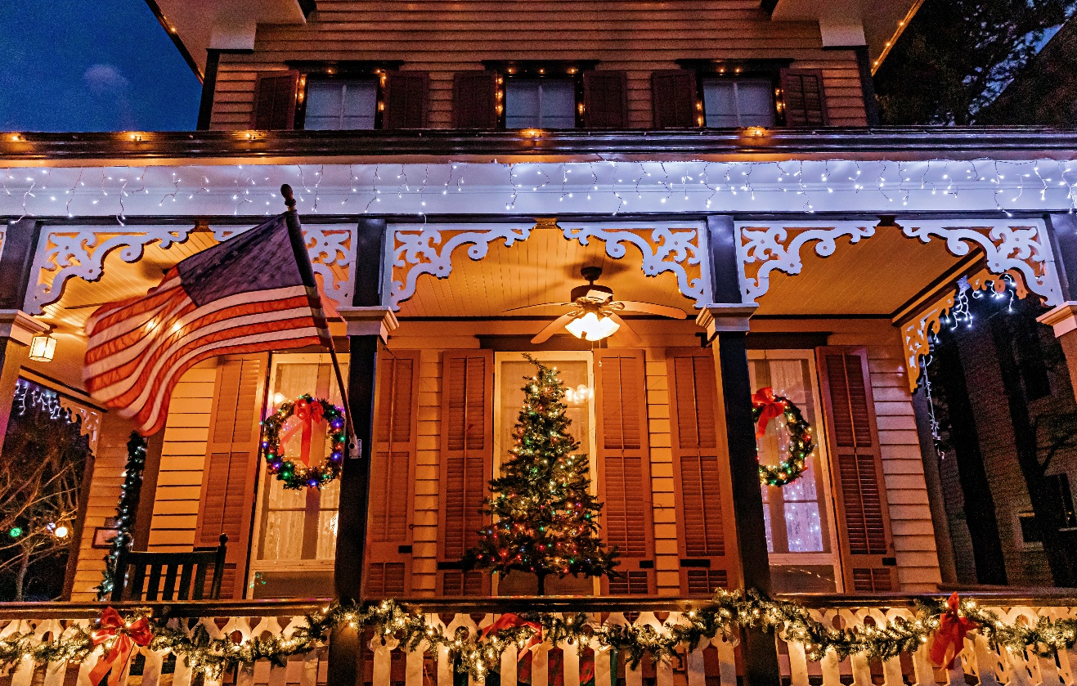
Photo courtesy of Cape May MAC
Cape May MAC Christmas Tours celebrate the beauty and joy of the holiday season in Cape May.

CAPE MAY – Cape May MAC (Museums+Arts+Culture) offers dozens of holiday tours, activities and events for visitors to Victorian Cape May over six weeks from Nov. 21 to Jan. 4, 2026. Visitors ready for holiday joy can celebrate the Christmas season amid the beauty and history of this National Historic Landmark City.
New for the 2025 Holiday Season
New! Step into the heart of the holiday season with the Caroling in Victorian Cape May Walking Tour, a festive caroling tour through the charming streets of Cape May. This magical experience combines the town’s Victorian elegance with the warmth and joy of classic Christmas carols. As you stroll through Cape May’s beautifully decorated streets, your guides will lead the group in singing traditional carols, from “Jingle Bells” to “Silent Night.” Along the way, you’ll hear interesting stories about the carols, themselves. Whether you’re a local or visiting for the season, this tour immerses you in Cape May’s holiday spirit, sharing the joy of song and community in one of the country’s most picturesque winter destinations. Tour begins and ends at the Washington Street Mall Information Booth, Ocean Street, Cape May. The tour is offered Nov. 30, Dec. 7, 14, 21, 28 at 3:30 p.m.
New! Holiday Inns Tour and Dinner at Washington Inn features dinner plus an afternoon Holiday Inns Tour from 1 p.m. to 3:30 p.m. in Cape May. Step inside several Cape May properties decorated for the holidays with garland, bows, trees and more. Capture the Christmas spirit as you see inside these Cape May landmark properties during the holiday season. This is a self-guided tour, so please bring your ticket to the Washington Street Mall Information Booth located at the junction of Washington and Ocean Streets to receive your copy of the map. A trolley shuttle makes a continuous loop during this self-guided afternoon tour. Dinner at 4 p.m. at the renowned Washington Inn includes an appetizer, entrée and dessert (gratuity not included). An optional wine pairing is available for purchase. The tours are Dec 4, 11 and 18.
New! On the Lamplighter Tour and Dinner at The Washington Inn, guests will have dinner at 4 p.m. at the renowned Washington Inn prior to their Lamplighter Christmas Walking Tour from 5:30 to 7:30 p.m. Dinner at the Washington Inn will include an appetizer, entrée and dessert (gratuity not included). An optional wine pairing is available for purchase. Enjoy Cape May's historic district decorated for Christmas in the evening on the Lamplighter Christmas Walking Tour. Stop and see inside a selection of Cape May bed & breakfast inns and private homes, specially decorated for the holidays on this self-guided evening walking tour that includes a visit to An Old-fashioned Christmas Exhibit in the Carroll Gallery at the Physick Estate Carriage House. Dec 5, 12, 19, 26 and 27.
New! On the Candlelight House Tour and Dinner at the Washington Inn, guests will have dinner at 4 p.m. at the Washington Inn prior to their Christmas Candlelight House Tour from 5:30 to 8:30 p.m. Dinner at the renowned Washington Inn will include an appetizer, entrée and dessert (gratuity not included). An optional wine pairing is also available for purchase. Cape May MAC launched this evening walking tour in 1974 and ever since it has been a highlight of the Christmas season in Victorian Cape May, America's only National Historic Landmark City. Stroll along gaslit streets and visit homes, inns, B&Bs, churches and hotels, most within walking distance of each other, to see lovely interiors decorated for the holidays. Dec. 20 only.
52nd Annual Christmas Candlelight House Tours
Cape May MAC launched its first Christmas tour in 1974, the Christmas Candlelight House Tour, and it is Cape May MAC’s most popular tour of the year. This 52nd year celebrates the best of Cape May at Christmas, as you walk along Cape May’s gaslit streets, hear musicians and carolers, and visit a large selection of homes, inns, B&Bs, churches and hotels where you’ll step inside to see both Victorian and more modern interiors beautifully decorated for the holidays. This self-guided walking tour centered in a 3/4-square-mile area of the Historic District is also Cape May MAC’s largest annual fundraiser. Ticket purchasers obtain a map and wristband the day before or day of the tour at the Physick Estate. Advance purchase is highly recommended. As in 2024, an express shuttle will operate between the Physick Estate and the one or two farthest points. Most properties are clustered within a 20-minute walk in the Historic District with some just a few minutes from each other, and that makes walking the most efficient way to see the most properties with the least time spent waiting. Wear your most comfortable walking shoes, dress in layers, and feel the holiday merriment as you explore participating properties on foot in Cape May's Historic District. Saturdays, Dec. 6, 13 and 20 from 5:30 p.m. to 8:30 p.m. Tickets sell out quickly.
More Historic House Tours
See Cape May’s Victorian House Museum, the 1879 Emlen Physick House, decorated in true Victorian style for Christmas on the Emlen Physick Estate Tour during the holidays. Your guide will take you through the first and second floors of the 18-room mansion, voted “the most beautiful building in New Jersey,” and explain its importance and the history of the family and staff who lived and worked here. Learn about Victorian Christmas traditions along the way. Afterwards, visit the Carroll Gallery in the estate’s Carriage House to see “An Old-Fashioned Christmas” exhibit, with a marvelous Dept. 56 Dickens Village display.
For those looking for a festive daytime tour, the Holiday Inns Tour is your ticket to step inside several Cape May properties decorated for the holidays with garland, bows, trees and more. Capture the Christmas spirit as you see inside these Cape May landmark properties during the holiday season. This is a self-guided tour, so please bring your ticket to the Washington Street Mall Information Booth located at the junction of Washington and Ocean Streets and get a copy of the map. A trolley shuttle makes a continuous loop during this afternoon tour.
See inside a selection of Cape May bed & breakfast inns and private homes, specially decorated for the holidays on Lamplighter Christmas Walking Tours, self-guided evening walking tours that include a visit to An Old-fashioned Christmas Exhibit in the Carroll Gallery at the Physick Estate Carriage House.
The Evening Yuletide House Tour is a guided, first-person living history holiday tour of first-floor rooms of the magnificent 1879 Physick Estate, Cape May’s only Victorian house museum, decorated in authentic Victorian style for Christmas. Your guide portrays a member of the Physick family in the early 1900s and shares stories and traditions. This evening tour also includes a visit to the Carroll Gallery to see “An Old-fashioned Christmas” exhibit.
For Children Young and Old
Mrs. Claus comes direct from the North Pole to lead Santa’s Trolley Rides this year. She tells stories and leads holiday songs on this jolly holiday trolley ride through town. Santa joins the fun on the grounds of the 1879 Emlen Physick Estate. Begins and ends at the Physick Estate, 1048 Washington St., except for the Saturday before Thanksgiving, the night of Christmas Tree Lighting at the estate, when all trolley tours begin and end at the Washington Street Mall Information Booth.
Share a delicious breakfast with family and friends and welcome special guest Santa Claus, himself, as he drops in at the Inn of Cape May, 7 Ocean St., and greets guests, on select dates leading up to Christmas. During Breakfast With Santa at The Inn of Cape May there will be time for photos and sharing of wish lists. Event is limited and sells quickly.
Since 2011, the yuletide display “An Old-Fashioned Christmas Exhibit: Holiday Traditions through the Years,” has been a beloved tradition of Cape May MAC’s festive holiday season. Hosted at the Carroll Gallery on the grounds of the 1879 Emlen Physick Estate, this charming exhibit has welcomed thousands of holiday visitors, both young and old, over the years. Experience holiday traditions complete with a stately Christmas tree, a Dept. 56 Dickens Village, model trains, nostalgic photos from Christmas past, toys and much more featuring an extensive Dept. 56 Dickens Village Collection from Ernie & Betsy Heegard. Open daily Nov. 21 through Jan. 4, 2025 (except Thanksgiving and Christmas Day). Admission is free.
Christmas Drama
In ’Tis The Season: The Trials of Tradition, visitors will step inside Cape May’s Victorian House Museum, the 1879 Physick House Museum, 1048 Washington St., and encounter the characters as this original story unfolds. Exhausted from the hustle and bustle of the holiday season and overwhelmed with a house full of guests, Carol Evans can’t remember why she even bothers at all. Her evening is interrupted when mysterious visitors arrive with their own stories to share. Can these mysterious visitors from Christmases past help restore tradition before it’s too late? Accessible with advance notice. Nov. 26, Dec. 3, 5, 10, 12, 17, 19.
The setting of the heartwarming dramatic comedy, “Let's Catch Santa,” is Christmas Eve. When a young woman new to the neighborhood attempts to return a misdelivered package, she meets her elderly neighbor for the first time. What begins as a simple favor turns into an unexpected adventure as she discovers his one holiday wish: to catch Santa Claus. This heart-warming play brings two lonely souls together, to find family in each other, truth within themselves and the fun, child-like belief in the timeless magic of Santa, Christmas and the holiday season! Nov. 19 to Dec. 28, Wednesday to Saturday 7 p.m., Sunday at 3 p.m., Cape May Stage, Robert Shackleton Playhouse, 405 Lafayette St.
Trolley Rides and Tours
Who can resist the sparkle of Cape May’s beautiful streetscapes and Victorian homes decorated for Christmas? On the Holiday Lights Trolley Ride hear Christmas music and the history of Victorian Christmas traditions as you travel in the evening to see the holiday lights. Bring a lap blanket to keep warm or snuggle with a loved one and get into the spirit of Christmas with friends and family on one of Cape May’s most popular holiday trolley tours. Tour begins and ends at the trolley stop on Ocean Street.
Step on board the evening Spirited Cape May Christmas Trolley Rides, and hear tales of Christmases long, long ago and not so long ago, as you travel along lovely streets in the historic district. Hear about Santa arriving at this seaside town in odd and surprising ways, ghostly appearances in the 1879 Physick House museum experienced and recorded by staff there during the holidays, ghostly shadow spirits out strolling on cold December nights, the weird and risky games Victorians played at Christmas, and more.
It’s the winter holiday season in the late Victorian age. Join All That Glitters: Victorians Ring In A New Century Trolley Tour and take a ride around town as we regale all with then and now stories of the lively Cape Island holiday social landscape of the time. Learn how Victorians of the late 1800s in Cape May celebrated the New Year’s holiday and hear about some of the traditions and customs of subsequent decades through today.
For schedules and tickets, visit capemaymac.org or call 609-884-5404. Schedule is subject to change.

Cape May MAC (Museums+Arts+Culture) is a multifaceted not-for-profit organization committed to promoting the preservation, interpretation, and cultural enrichment of the Cape May region for its residents and visitors. We maintain and manage the 1879 Emlen Physick Estate, the 1859 Cape May Lighthouse and the 1942 World War II Lookout Tower, and are the leading organization to offer visitors tours, activities and events year-round in America’s National Landmark City. Cape May MAC is the organization that saved the 1879 Emlen Physick Estate from demolition in 1970 and helped secure Cape May’s renaissance as a historic tourist destination. For information about our year-round schedule of tours, festivals, and special events, call 609-884-5404 or visit capemaymac.org. For information about restaurants, accommodations and shopping, call the Chamber of Commerce of Greater Cape May at 609-884-5508.

###

