

CONTACT: Susan Krysiak For Immediate Release
Director of Media Relations Oct. 23, 2025
609-224-6036
skrysiak@capemaymac.org

Cape May’s Holiday Preview Weekend features Santa arriving to light the Physick Estate Christmas tree

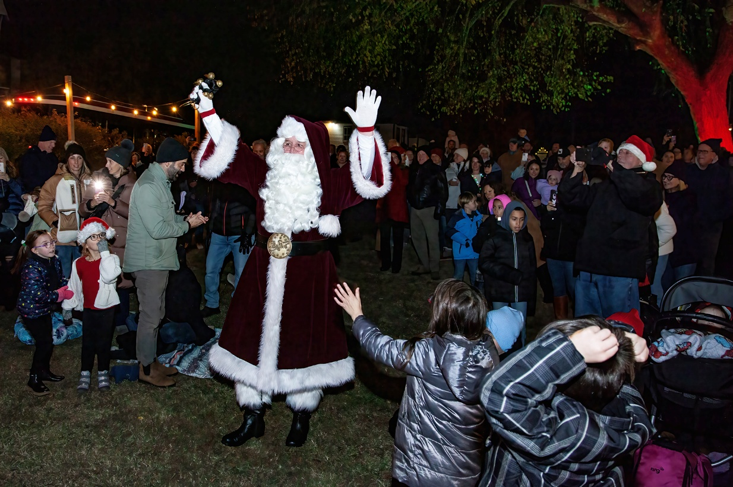

Photos courtesy of Cape May MAC
Santa arrives during the annual Christmas Tree Lighting at the Emlen Physick Estate, 1048 Washington St., Cape May.

CAPE MAY – Christmas arrives in Victorian Cape May with great fanfare during Holiday Preview Weekend in Cape May, Nov. 21-23, presented by Cape May MAC (Museums+Arts+Culture), at the Emlen Physick Estate, 1048 Washington St. The weekend launches six weeks of tours, activities and events especially for the Christmas season.
It’s a yearly Cape May tradition and kicks off the holiday season! Santa Claus, himself, flips the switch and illuminates the huge evergreen Christmas tree on the grounds of the historic 1879 Emlen Physick Estate, 1048 Washington St. during the annual Christmas Tree Lighting Ceremony, Saturday, Nov. 22, from 5 p.m. to 8 p.m. Everyone is welcome! Visitors of all ages are invited to this annual tradition outdoors on the grounds of the estate, a thrilling start to the holiday season, presented by Cape May MAC and sponsored by Sturdy Savings Bank. Visitors are invited to bring canned goods and non-perishable food items for collection during the evening to donate to the Cape May Community Food Bank, which helps feed needy families in the community, and stop by the Toys for Tots table to help support this worthy cause. This year features the John Walters Community Band performing holiday favorites on the outdoor stage. Browse among vendors on the grounds and grab a cup of hot cocoa. The concert begins at 5:30 p.m. Santa will arrive to hit the lights on the huge Christmas tree on the estate at 7 p.m. from the outdoor stage.

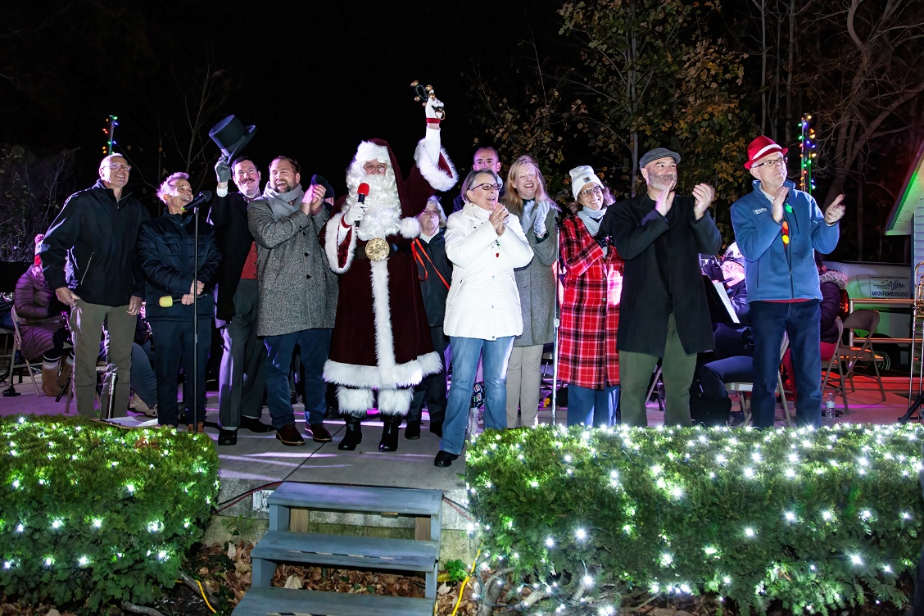
The 1879 Physick House Museum is authentically decorated for a Victorian Christmas during the holiday season and visitors on Saturday, Nov. 22 can step inside the museum for a free, self-guided Physick Estate Christmas Tour, from 5 p.m. to 8 p.m.
The wonders of the season are on display beginning Nov. 21 in An Old-fashioned Christmas Exhibit in the Carroll Gallery at the Physick Estate’s Carriage House. Stand beneath the boughs of a giant Christmas tree! This exhibit features holiday traditions through the years that bring to life a child’s Christmas fantasy, complete with a delightful Dept. 56 Dickens Village, model trains, vintage Christmas family photos, toys and much more. Admission is free.
The best way to see Cape May’s Christmas lights during Holiday Preview Weekend is on board Holiday Lights Trolley Rides. Ride through Cape May’s Historic District and see cheerfully decorated inns and homes as guides talk about Victorian Christmas traditions and play Christmas music. Rides last about 30 minutes and all season long they depart from the Ocean Street Trolley stop, except for the night of Christmas Tree Lighting, Nov. 22, at 6:15 p.m., 7:15 p.m. and 8:15 p.m., when they depart from the Emlen Physick Estate.
Step on board for Spirited Cape May Christmas Trolley Rides during the Christmas season in historic Cape May! Hear tales of Christmases long, long ago and not so long ago, as you travel along lovely streets in the historic district. Hear about Santa arriving at this seaside town in odd and surprising ways, ghostly appearances in the 1879 Physick House museum experienced and recorded by staff there during the holidays, ghostly shadow spirits out strolling on cold December nights, the weird and risky games Victorians played at Christmas, and more.
Cape May MAC’s two museum shops, the Carriage House Museum Shop at the Emlen Physick Estate, 1048 Washington St., and the Cape May Lighthouse Museum Shop, at the Cape May Lighthouse, 215 Lighthouse Ave. are fully accessible and open for extended hours throughout the holiday season. They offer museum quality gift ideas for the Cape May lover, including jewelry, silk scarves and ties, tea, books, Cape May apparel and more at the Carriage House Museum Shop, as well as locally crafted items and items designed in New York especially for the Emlen Physick Estate. There are selections for youngsters as well, including a curated selection of educational children’s books, toys, clothing, and plush toys. At the Cape May Lighthouse Museum shoppers will find toys, books and clothing, much not found anywhere else, for fans of the lighthouse. Parking is free at both locations. Proceeds from both of Cape May’s museum shops benefit Cape May MAC’s historic preservation efforts. The Online Museum Shop is available wherever you are. For more information visit capemaymac.org.
Tickets may be purchased in advance by phone at 609-884-5404, online at capemaymac.org or in person by visiting Hill House Visitor Service Center or Carriage House Visitor Service Center, both at the Emlen Physick Estate, 1048 Washington St., or the Washington Street Mall Information Booth at Washington Street at Ocean Street.
Cape May MAC (Museums+Arts+Culture) is a multifaceted not-for-profit organization committed to promoting the preservation, interpretation, and cultural enrichment of the Cape May region for its residents and visitors. Cape May MAC maintains and manages the 1879 Emlen Physick Estate, the 1859 Cape May Lighthouse and the 1942 World War II Lookout Tower, and is the leading organization to offer visitors tours, activities and events year-round in America’s National Landmark City. Cape May MAC is the organization that saved the 1879 Emlen Physick Estate from destruction in 1970 and helped secure Cape May’s renaissance as a historic tourist destination. For information about the year-round schedule of tours, festivals and special events, call 609-884-5404 or visit capemaymac.org.
###

