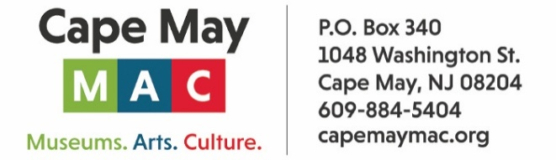

CONTACT: Susan Krysiak For Immediate Release
Director of Media Relations Dec. 19, 2025
609-224-6036
skrysiak@capemaymac.org
Brenda Leonard
bleonard@capemaymac.org

Classical Cape May series continues this winter

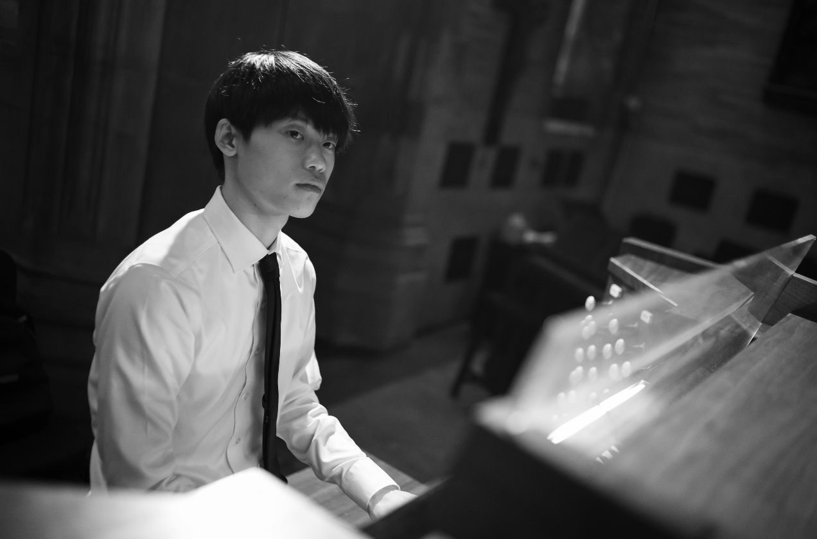
Provided
A rising young star on the organ, Eddie Zheng performs “Organ Masterworks” on Sunday, March 8 as part of the Classical Cape May series.

CAPE MAY — Classical Cape May, in partnership with the annual Cape May Music Festival presented by Cape May MAC (Museums+Arts+Culture) and supported in part by a grant from the New Jersey State Council on the Arts, continues its 2025-26 season of concerts this winter and spring.
Concerts are held at the Episcopal Church of the Advent, 612 Franklin St. (Franklin and Washington streets) Cape May, from 4 p.m. to 5 p.m. and admission is free. Goodwill offerings are graciously accepted and help support the cost of programming. Attendees are invited to a reception after each program to meet the artists.
Sunday, Dec. 26
Christmas Hymn Sing-Along
Sing carols and hymns on Boxing Day, Dec. 26, in a joyful celebration presented by Classical Cape May, Cape May MAC and the Episcopal Church of the Advent. Led by local musicians including organist Tom Crawford, this festive Christmas hymn sing invites all ages to come together in song and spirit. Bring the whole family and lift your voices in favorite carols and hymns. Start a new family tradition with us!
Sunday, Jan. 11
American Ethos
Carolyn Enger, piano
Acclaimed New Jersey pianist Carolyn Enger presents American Ethos, a powerful program that celebrates the rich diversity of American composers. Through selections by Leonard Bernstein, Florence Price, Ned Rorem, and others, Ms. Enger shines a light on often-overlooked voices who reflect the unique spirit and cultural mosaic of our nation. This recital invites us to listen deeply to the many threads that make up the American musical landscape.
Sunday, Feb. 8
Perfect Harmony
Christopher and Karen DiSanto, clarinets, Piang Liang, bassoon
Hear a program of rich and colorful chamber music featuring clarinetists Christopher DiSanto and Karen DiSanto and bassoonist Ping Liang, all members of the Bay Atlantic Symphony. This talented trio brings warmth, virtuosity, and a deep musical connection to the stage. Their program will feature an engaging mix of repertoire including works by Mozart, Beethoven, Stravinsky and others.
Sunday, March 8
Organ Masterworks
Eddie Zheng, organ
Organist Eddie Zheng, one of the brightest rising stars in today’s classical music scene, comes to Cape May. With three degrees from The Juilliard School and an international performance career already spanning the world, Mr. Zheng brings dazzling technique and fresh insight to every program. His program explores how three composers — Bach, Wagner, and Liszt — write music of anticipation and yearning for the organ. From the Advent chorales of Nun komm, der Heiden Heiland to the operatic finale of Tristan und Isolde, and the vast symphonic vision of Liszt’s Ad nos, ad salutarem undam, each work offers its own vision of light through the organ.
Sunday, April 12
Encore: Mostly Motets
Mostly Motets Chamber Choir
The final concert of the season is a return performance by Mostly Motets, a chamber choir featuring singers from Pennsylvania and New Jersey. Known for their expressive blend and elegant interpretations, the group offers a program of vocal works spanning centuries and styles. Whether Renaissance polyphony or contemporary gems, Mostly Motets brings clarity, warmth, and precision to every performance—an intimate and inspiring finale to our season.
Classical Cape May is co-founded and co-directed by Brenda Leonard and Robert Bullington. The mission is to bring a variety of free classical performances to Cape May during the winter season, and to celebrate local and regional classical music talent. The series is open to all ages and interests, and donations are most welcome. classicalcapemay.com.
Cape May MAC (Museums+Arts+Culture) is a multifaceted not-for-profit organization committed to promoting the preservation, interpretation, and cultural enrichment of the Cape May region for its residents and visitors. Funding has been made possible in part by the Preserve New Jersey Historic Preservation Fund/State of New Jersey. Cape May MAC has received an operating support grant from the New Jersey Historical Commission, a division of the Department of State. Arts programs are made possible by funds from the New Jersey State Council on the Arts, a partner agency of the National Endowment for the Arts. Cape May MAC maintains and manages the 1879 Emlen Physick Estate, the 1859 Cape May Lighthouse and the 1942 World War II Lookout Tower, and is the leading organization to offer visitors tours, activities and events year-round in America’s only National Historic Landmark City. Cape May MAC membership is open to all. capemaymac.org.

