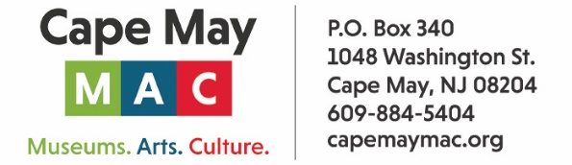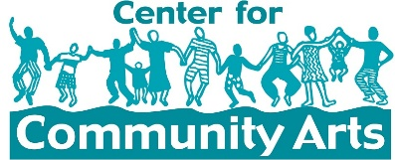

CONTACT: Susan Krysiak For Immediate Release
Director of Media Relations Dec. 26, 2025
609-224-6036
skrysiak@capemaymac.org

‘Black Legacy of Historic Cape May: Unexpected History’ Carroll Gallery exhibit opens Jan. 16
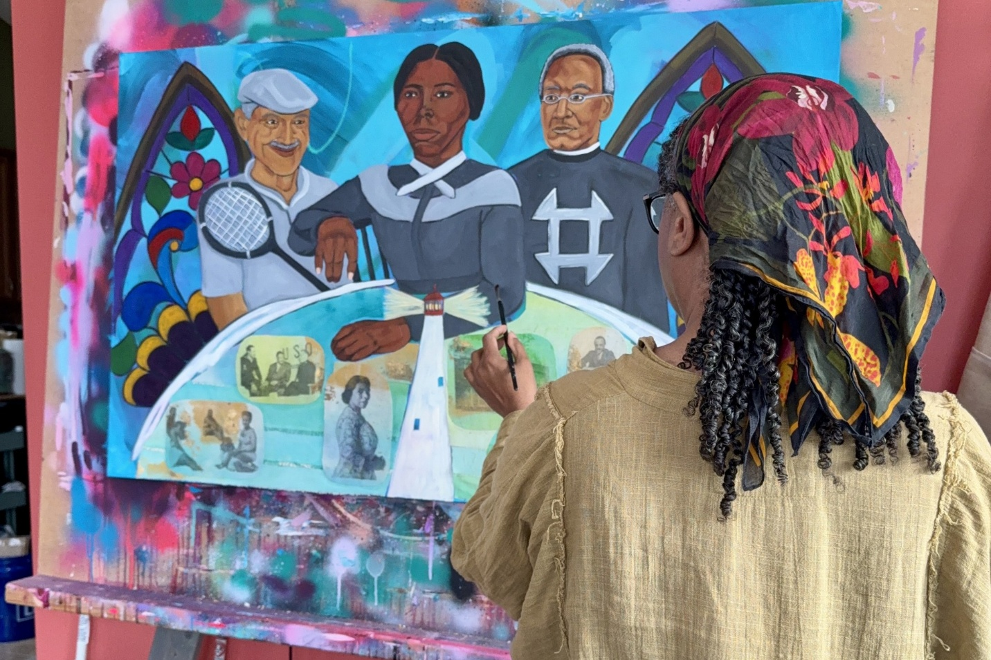
Photo courtesy of Chanelle René
Shown here, artist Chanelle René with her new work, “Beacons of Cape May.” The work was commissioned by Cape May MAC for the exhibit “Black Legacy of Historic Cape May: Unexpected History,” open Jan. 16 hrough April 12, 2026.

CAPE MAY, N.J. – A new Carroll Gallery exhibit, “Black Legacy of Historic Cape May: Unexpected History,” at the Emlen Physick Estate, 1048 Washington St., opens Martin Luther King, Jr. weekend with an opening reception on Friday, Jan. 16, 2026, at 5 p.m. The exhibit heralds renowned Black residents and visitors of Cape May.
Cape May’s Black residents have shaped the city’s identity in many ways, creating a legacy extensively documented and officially recognized in 2024 as important to the rich culture of the city, elevating and enhancing the city's National Historic Landmark status. Prominent Black abolitionists, civil rights leaders, business leaders, educators and artists made Cape May a part of their lives in widely known and lesser-known ways.
The town hosted influential figures like Marian Anderson, Paul Robeson, W.E.B. Du Bois, and Martin Luther King, Jr., leaving a legacy of culture, activism, and resilience. Learn about renowned Black residents and visitors who were part of the fabric of Cape May life in their time, or who made this lively town a stop on their spectacular journey to achievement.
This exhibit explores that rich history and features a new, original painting commissioned by Cape May MAC entitled, “Beacons of Cape May,” by the exhibit’s contributing artist Chanelle Rene’, of Cape May County.
“‘Beacons of Cape May’ honors the powerful legacy of African Americans who shaped the city’s cultural and civic landscape,” René said. “The painting centers Harriet Tubman, Rev. Stephen Smith, and William J. Moore, framed by stained-glass windows that echo the historic Black churches of Cape May. At the heart of Tubman’s apron, the Cape May Lighthouse shines as a symbolic beacon of guidance, resilience and safe passage.
“Surrounding this light, fabric collage panels feature printed swatches of figures such as Marian Anderson, Paul Robeson, and Jarena Lee, representing the many Black artists, leaders, and community builders who lived, worked, and visited Cape May. Through layered oil paint, fabric, and a vibrant spray-painted underpainting, the work weaves together memory, place, and collective heritage — illuminating a lineage that continues to inspire.”
“Black Legacy of Historic Cape May: Unexpected History” is presented by Cape May MAC (Museums+Arts+Culture) in association with Center for Community Arts (CCA), at the Carroll Gallery, Emlen Physick Estate, 1048 Washington St. The exhibit opens the weekend of the Martin Luther King, Jr. holiday with a reception Friday, Jan. 16, at 5 p.m. open to all, with refreshments, and features a gospel choir organized by Cape May Macedonia Baptist Church members. The exhibit is open through April 12, 2026. Admission is free. For schedule visit capemaymac.org.
The Center for Community Arts (CCA) is a multicultural education organization whose arts and humanities programs foster creativity, community building, and appreciation for the rich diversity of our world. centerforcommunityarts.org.
Cape May MAC (Museums+Arts+Culture) is a multifaceted not-for-profit organization committed to promoting the preservation, interpretation, and cultural enrichment of the Cape May region for its residents and visitors. Funding has been made possible in part by the Preserve New Jersey Historic Preservation Fund/State of New Jersey. Cape May MAC has received an operating support grant from the New Jersey Historical Commission, a division of the Department of State. Arts programs are made possible by funds from the New Jersey State Council on the Arts, a partner agency of the National Endowment for the Arts. Cape May MAC maintains and manages the 1879 Emlen Physick Estate, the 1859 Cape May Lighthouse and the 1942 World War II Lookout Tower, and is the leading organization to offer visitors tours, activities and events year-round in America’s only National Historic Landmark City. Cape May MAC membership is open to all. For information about Cape May MAC’s year-round schedule of tours, festivals and events, visit capemaymac.org or call 609-884-5404.

###

