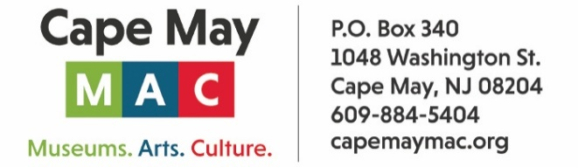

CONTACT: Susan Krysiak For Immediate Release
Director of Media Relations Dec. 19, 2025
609-224-6036
skrysiak@capemaymac.org

Exploring Literary Greats, Four Online Seminars with Cape May Poet Laureate Sylvia Baer
Delve into “Gilgamesh," "The Tempest" and "Othello," "Leaves of Grass," and "The Old Man and the Sea" this February

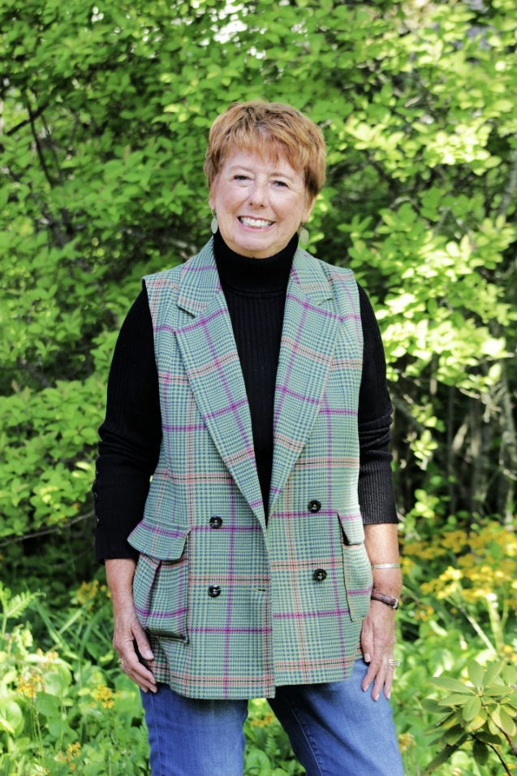
Photo courtesy of Cape May MAC
Cape May Poet Laureate Sylvia Baer, Ph.D.

CAPE MAY — Cape May’s Poet Laureate Sylvia Baer hosts four 1.5-hour interactive online seminars via Zoom this February that will delve into literature that explores what it means to be human in Exploring Literary Greats, Four Online Seminars. The class will delve into “Gilgamesh," Shakespeare's "The Tempest" and "Othello," Walt Whitman's "Leaves of Grass," and Hemingway's "The Old Man and the Sea." These online seminars are designed for those at any level of knowledge and experience who wish to learn more about literature. This will be an engaging, interactive learning experience. Participants will not be recorded, but video cameras shall be on to encourage the energetic flow of ideas and active participation. Reading selections will be provided in advance at no extra cost but are not required reading. Each participant will be sent a Zoom link and further information after ticket purchase.
Seminars are scheduled for 6 p.m. to 7:30 p.m. on the following dates: “The Epic of Gilgamesh” on Feb. 2; “The Tempest and Othello” on Feb. 9; “Leaves of Grass” on Feb. 16; and “The Old Man and the Sea” on Feb. 23. For more information visit https://capemaymac.org/exploring-literary-greats/.
Dr. Sylvia Baer has been a professor of literature for 52 years and is also the Poet Laureate of Cape May, a playwright, a memoirist, a writer of scholarly works, a translator of Spanish poetry (into English), and a Fellow at Yale University. She has curated haiku and photography exhibitions at Rowan University and Yale University, been founding editor of international academic journals, and presented at conferences and workshops throughout the country. In Cape May she is the creator of The Poet-Tree where she hangs about 60 poems written by a whole panoply of writers, and with signage encourages passers-by to pick any poem that appeals to them and to take it with them. So many enjoy this that each day the tree is replenished once or twice. Her latest book, “Building Life, A Memoir,” published in June 2024, is the second volume in an unconventional memoir that began with “Learning Life, a Memoir, published in August 2022. Both are published by Nostos Press. She has deep connections to Cape May MAC, spanning five decades, and can proudly say that her father was the first president of Cape May MAC in 1971.
Cape May MAC (Museums+Arts+Culture) is a multifaceted not-for-profit organization committed to promoting the preservation, interpretation, and cultural enrichment of the Cape May region for its residents and visitors. Funding has been made possible in part by the Preserve New Jersey Historic Preservation Fund/State of New Jersey. Cape May MAC has received an operating support grant from the New Jersey Historical Commission, a division of the Department of State. Arts programs are made possible by funds from the New Jersey State Council on the Arts, a partner agency of the National Endowment for the Arts. Cape May MAC maintains and manages the 1879 Emlen Physick Estate, the 1859 Cape May Lighthouse and the 1942 World War II Lookout Tower, and is the leading organization to offer visitors tours, activities and events year-round in America’s only National Historic Landmark City. Cape May MAC membership is open to all. capemaymac.org.

