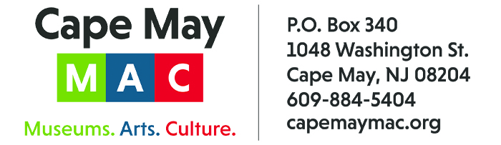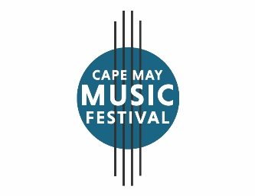

CONTACT: Susan Krysiak For Immediate Release
Director of Media Relations Feb. 27, 2026
609-224-6036
skrysiak@capemaymac.org

Cape May Music Festival opens with ‘WCC@100: The Westminster Choir Looks Forward’ May 9

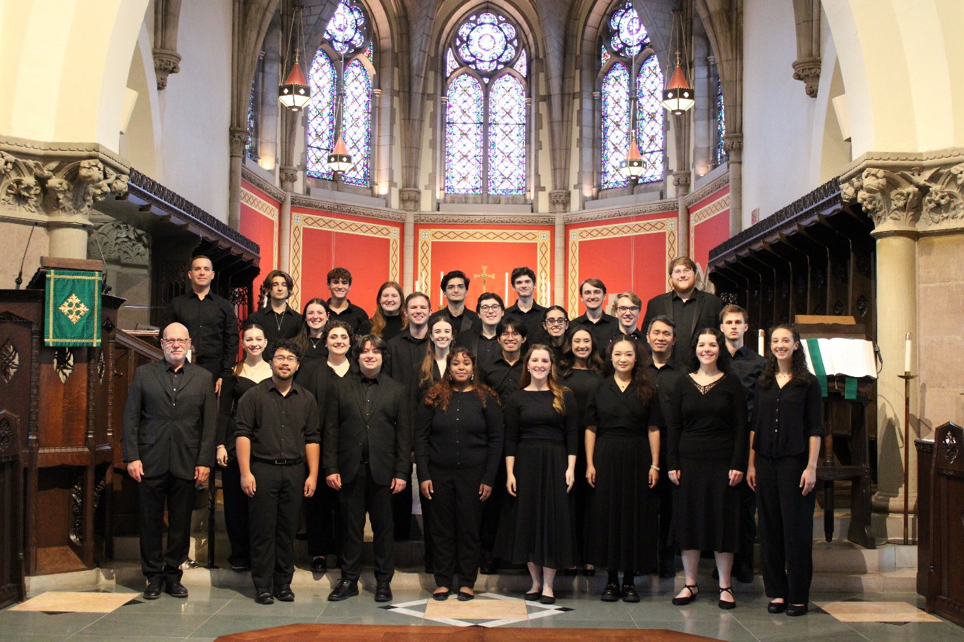
Courtesy of Westminster Choir College

CAPE MAY, N.J. - Performing a program celebrating the rich history of choral music, Cape May MAC (Museums+Arts+Culture) welcomes the renowned Westminster Choir of Westminster Choir College in New Jersey to open the 37th Annual Cape May Music Festival, Saturday, May 9 at 7 p.m., at the Episcopal Church of the Advent, 712 Franklin St.
“Westminster Choir presents WCC@100: The Westminster Choir Looks Forward” features The Westminster Choir, Donald Nally, conductor with Scott Dettra, organ. The Westminster Choir celebrates the college's 100th anniversary with a program featuring distinguished alumni as conductor and organist and works from the rich history of choral music. Brahms, the height of the Romantic era, and Howells, the pinnacle of the English 20th-century Renaissance look back, while mystical minimalism is represented by its master Arvo Pärt in his iconic, Salve regina. Finally, a virtuosic contemporary work from American composer Stacy Garrop based on the writings of Lydia Davis is an exploration of aging, told through the metaphor of decay and dissolution in a house besieged.
The Westminster Choir has been at the forefront of American choral music since its founding. Praised by The New York Times for its “full-bodied, incisive singing,” the Westminster Choir also forms the core of the Westminster Symphonic Choir, which has recorded and performed with major orchestras under virtually every internationally acclaimed conductor of the past 89 years. The choir is conducted by Dr. Donald Nally, ’87.
Nally is one of the nation’s leaders in the field of conducting. He holds the title of John W. Beattie Chair of Music Emeritus at Northwestern University, and is a frequent guest artist at universities. His previous academic appointments include Yale, Harvard and the University of Chicago. He has commissioned nearly 200 works and produced 33 recordings with his ensemble, The Crossing, winning three Grammy Awards for Best Choral Performance. In 2019, Rider University awarded Nally an honorary Doctorate of Humanities.
Nally has also held distinguished tenures as chorus master for the Lyric Opera of Chicago, Welsh National Opera and Opera Philadelphia. He has prepared choruses for numerous internationally recognized conductors with the Philadelphia Orchestra, New York Philharmonic and Los Angeles Philharmonic, among others. His 72-chapter series Rising w/ The Crossing, a response to the coronavirus pandemic, has been preserved by the National Archives of the Library of Congress as a cultural artifact.
The Westminster Choir College holds an elite, world-renowned reputation as a premier institution for choral music, vocal performance and pedagogy, often cited as a gold standard in American choral music. It is highly regarded for training leaders in vocal arts, church music, and music education. The college is known for producing high-caliber ensembles that have performed with major orchestras for over 87 years. The choir has recorded with renowned orchestras and performed at prestigious venues like Carnegie Hall.
Tickets are $35 adults, $30 Cape May MAC members, $20 students and can be purchased in advance online at capemaymac.org or at the door. The 37th Annual Cape May Music Festival features 14 classical, jazz, brass band, and choral performances from May 9 through June 21, in a seaside celebration of classical and contemporary music. For more information visit capemaymac.org or call 609-884-5404.
Cape May MAC (Museums+Arts+Culture) is a multifaceted not-for-profit organization committed to promoting the preservation, interpretation, and cultural enrichment of the Cape May region for its residents and visitors. Funding has been made possible in part by the Preserve New Jersey Historic Preservation Fund/State of New Jersey. Cape May MAC has received an operating support grant from the New Jersey Historical Commission, a division of the Department of State. Arts programs are made possible by funds from the New Jersey State Council on the Arts, a partner agency of the National Endowment for the Arts. Cape May MAC maintains and manages the 1879 Emlen Physick Estate, the 1859 Cape May Lighthouse and the 1942 World War II Lookout Tower, and is the leading organization to offer visitors tours, activities and events year-round in America’s only National Historic Landmark City. Cape May MAC membership is open to all. capemaymac.org.

###

