

CONTACT: Susan Krysiak For Immediate Release
Director of Media Relations Dec. 26, 2025
609-224-6036
skrysiak@capemaymac.org

‘Revolutionary Cape May’ Welcome Center exhibit features local role in nation’s fight for independence

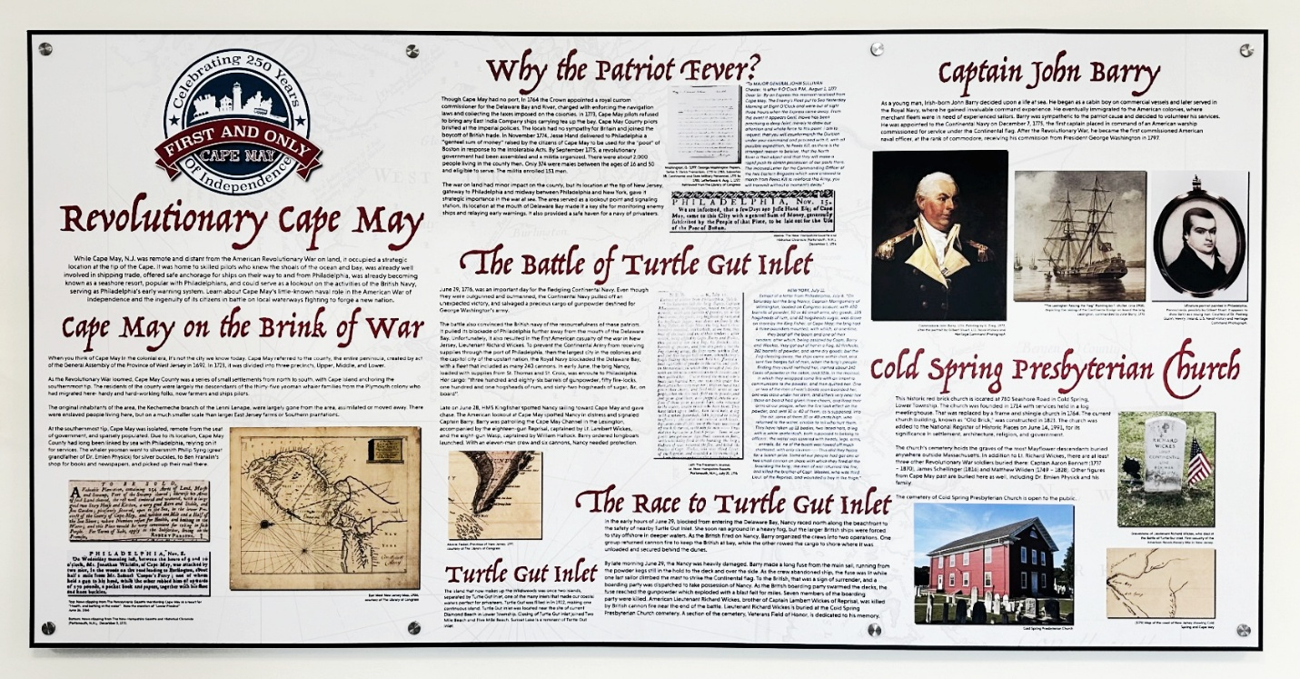
Photo courtesy of Cape MAC
Photo Caption: Shown here, one of four interpretive panels in a special Cape May MAC exhibit in Cape May's Welcome Center that explores the city’s role in the American War for Independence. The exhibit will be open through Jan. 4, 2027, as part of the nation's 250th anniversary celebration of the signing of the Declaration of Independence.

CAPE MAY, N.J. – A new Cape May MAC (Museums+Arts+Culture) exhibit at the Cape May Welcome Center, 609 Lafayette St., is open to the public through Jan. 4, 2027, and explores how Cape May made a difference in the American Revolutionary War (1775-1783).
While Cape May was remote and distant from the war on land, it occupied a strategic location at the tip of the Cape. It was home to skilled pilots who knew the shoals of the ocean and bay, was already well involved in shipping trade, offered safe anchorage for ships on their way to and from Philadelphia, was already becoming known as a seashore resort, popular with Philadelphians, and could serve as a lookout on the activities of the British Navy, serving as Philadelphia’s early warning system.
Learn about Cape May’s little-known naval role in the American War of Independence and the ingenuity of its citizens in battle on local waterways fighting to forge a new nation.
The public is invited to attend an Exhibit Opening at the Welcome Center on Friday, Jan. 2, at 4 p.m. Discover something new, sample a Cape May Farmhouse pale ale from Cold Spring Brewery, and celebrate Cape May’s unique place in history. Admission is free.
Cape May MAC is a multifaceted not-for-profit organization committed to promoting the preservation, interpretation, and cultural enrichment of the Cape May region for its residents and visitors. Funding has been made possible in part by the Preserve New Jersey Historic Preservation Fund/State of New Jersey. Cape May MAC has received an operating support grant from the New Jersey Historical Commission, a division of the Department of State. Arts programs are made possible by funds from the New Jersey State Council on the Arts, a partner agency of the National Endowment for the Arts. Cape May MAC maintains and manages the 1879 Emlen Physick Estate, the 1859 Cape May Lighthouse and the 1942 World War II Lookout Tower, and is the leading organization to offer visitors tours, activities and events year-round in America’s only National Historic Landmark City. Cape May MAC membership is open to all. capemaymac.org.

###

