

CONTACT: Susan Krysiak For Immediate Release
Director of Media Relations March 18, 2026
609-224-6036
skrysiak@capemaymac.org

‘Once in a Hundred Years: The Life and Legacy of Marian Anderson’ film at Cape May Stage April 4

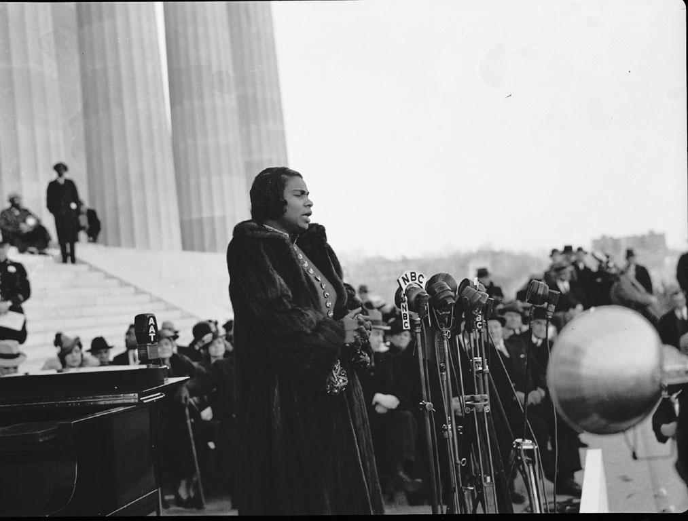
Photo Credit: “Marian Anderson Sings at Lincoln Memorial: 1939 # 1” by Washington Area Spark, CC BY-NC 2.0

CAPE MAY – The Emmy award-winning documentary film, “Once in a Hundred Years: The Life & Legacy of Marian Anderson,” will be presented Saturday, April 4 at 2 p.m. at Cape May Stage Theater in partnership with Cape May MAC (Museums+Arts+Culture). Admission is free, but donations will be collected to benefit the Cape May Community Food Closet. This film screening continues the celebration of Black History Month.
Once in a Hundred Years is an award-winning film that tells the story of contralto and civil rights activist Marian Anderson, of Philadelphia, who reached the pinnacle of professional achievement, attaining worldwide fame and an honored place in classical music history, as one of the greatest opera singers of all time.
When I sing, I don’t want people to see that my face is Black, I don’t want them to see that my face is white, I want them to see my soul which is colorless.
Marian Anderson
Marian Anderson has connections to Cape May. She performed here early on in her career, as detailed in advertisements in local newspapers. For more about her connection to Cape May, visit the Carroll Gallery Exhibit, “Black Legacy of Historic Cape May: Unexpected History,” in the Carriage House on the grounds of the Emlen Physick Estate, 1048 Washington St. Prominent Black abolitionists, civil rights leaders, business leaders, educators and artists made Cape May a part of their lives in widely known and lesser-known ways. The town hosted influential figures like Anderson, Paul Robeson, W.E.B. Du Bois, and Martin Luther King, Jr., leaving a legacy of culture, activism, and resilience. Learn about renowned Black residents and visitors who were part of the fabric of Cape May life in their time, or who made this lively town a stop on their spectacular journey to achievement. The exhibit is open through April 12.
Once in a Hundred Years was directed by Bill Nicoletti, of Ocean City, N.J., founder of Going the Distance Films, Philadelphia. The film was released in February 2018 and premiered at The Kimmel Center in Philadelphia to a sold-out audience, was featured at The Kennedy Center in New York and has aired on PBS. Cape May MAC and the Friends of the Cape May Music Festival presented a screening of the film at the Harbor Square Theater in Stone Harbor in 2020. The film’s title comes from a quote by famed conductor Arturo Toscanini who told her, "A voice like yours is heard once in a hundred years."
Cape May MAC (Museums+Arts+Culture) is a multifaceted not-for-profit organization committed to promoting the preservation, interpretation, and cultural enrichment of the Cape May region for its residents and visitors. Funding has been made possible in part by the Preserve New Jersey Historic Preservation Fund/State of New Jersey. Cape May MAC has received an operating support grant from the New Jersey Historical Commission, a division of the Department of State. Arts programs are made possible by funds from the New Jersey State Council on the Arts, a partner agency of the National Endowment for the Arts. Cape May MAC maintains and manages the 1879 Emlen Physick Estate, the 1859 Cape May Lighthouse and the 1942 World War II Lookout Tower, and is the leading organization to offer visitors tours, activities and events year-round in America’s only National Historic Landmark City. Cape May MAC membership is open to all. capemaymac.org.
###

