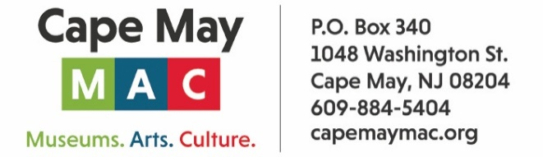

CONTACT: Susan Krysiak For Immediate Release
Director of Media Relations Dec. 19, 2025
609-224-6036
skrysiak@capemaymac.org

Presidents’ Day Weekend in Cape May features dozens of tours, activities, events

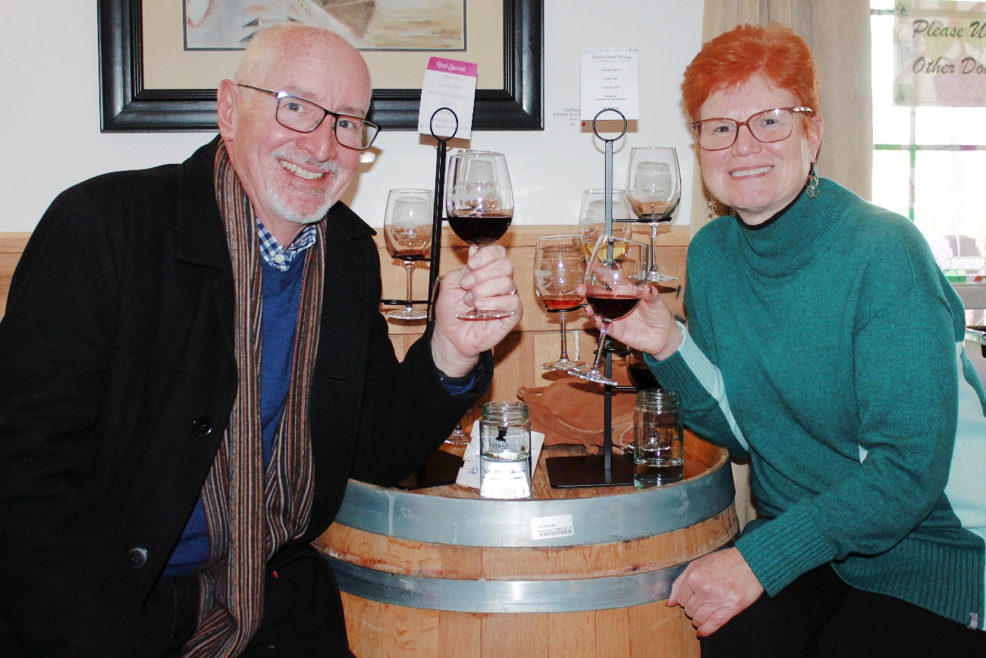
Photo courtesy of Cape May MAC
Shown here, friends enjoy a recent winter Cape May Wine Trail. The Cape May Wine Trail on Saturday, Feb. 14 features visits to two county wineries with trolley transportation and lunch included.

CAPE MAY — Presidents' Day Weekend, Feb. 13-16, includes Valentine's Day this year, and there’s a surprising array of things to enjoy in Cape May with tours, activities and events presented by Cape May MAC (Museums+Arts+Culture). Cape May MAC’s main mission is promoting the preservation, interpretation, and cultural enrichment of the Cape May region for its residents and visitors. Cape May County residents: this holiday weekend is a great time to explore your hometown.
Cape May Wine Trail
Cape May County vineyards are producing delicious wines and here is your chance to enjoy them with round-trip transportation via Cape May MAC trolley. Board the trolley at the Emlen Physick Estate, 1048 Washington St., and travel to Bellevue Tavern in Cape May Court House for a delicious lunch. Then it’s back on board the trolley for an afternoon of touring and sampling wine selections by vintners at Jessie Creek Winery and Briganti By the Bay Vineyard and Winery. Guests will receive a souvenir tasting glass at Jessie Creek Winery and an educational tasting and tour at Briganti By the Bay Vineyard and Winery. This event is for adults ages 21 and over.
Brunch & Bingo at the Inn of Cape May
Laugh along with your friends and make new ones as you play a little bingo, compete for prizes and enjoy a fashion show by Lace Silhouettes/Cotton Company. It’s all over a scrumptious breakfast buffet at The Inn of Cape May, 7 Ocean St. Cape May.
Channeling Dinner with Craig McManus
Enjoy a three-course prix fixe dinner at the Inn of Cape May followed by a two-hour channeling session with Medium Craig McManus. McManus will read the energies in the room and channel messages from the spirits of departed family and friends. While he does not read everyone present and cannot control where messages come through, he will bring through as many messages from spirits as possible during the two-hour channeling. Inn of Cape May, 7 Ocean St. This event is not recommended for people under the age of 16. No refunds within 14 days of the event.
Historic District Trolley Tours
Take this classic Cape May trolley tour and enjoy this seaside resort in winter! Tour guides will explain Cape May’s history and architecture and how and why it has survived and thrives to this day. Begins and ends at the Ocean Street Trolley Stop. Bring a blanket to snuggle in!
Emlen Physick Estate Guided Tours
Gain insight into architectural features within the 1879 Emlen Physick House and learn about the lives of one Victorian family, as you tour Cape May's Victorian House Museum, voted New Jersey's prettiest building by popular vote! For the fullest experience, combine this tour with a Historic District Trolley Tour.
Underground Railroad Trolley Tour
Cape May was part of the Underground Railroad and this trolley tour, part of the National Park Service's Network to Freedom and one of just 13 sites nationwide on the Park Service's Travels with Tubman app, tells of those dangerous days. Hear how legendary anti-slavery fighter, Harriet Tubman, walked these streets, as did prominent railroad businessman and former enslaved person, Stephen Smith, whose railroad cars carried hundreds to freedom. Portions of this tour are not accessible. Offered Monday, Feb. 17 at 11 a.m. Begins and ends at Ocean Street Trolley Stop.
Cape May Lighthouse
Bundle up! Challenge yourself to climb the 199 steps up the original, cast-iron spiral stairway to the top of the 1859 Cape May Lighthouse this winter and see a staggering view of the Delaware Bay and Atlantic Ocean, the surrounding nature trails of Cape May Point State Park, and Cape May Point Borough.
Mansions by the Sea Trolley Tour
You’ll hear how the rich lived in the early 1900s in the most elegant part of town on this trolley tour that includes the eastern beachfront. Today, new, beachfront second homeowners have continued the tradition, running the gamut from the mere wealthy to the fabulously rich. Offered Saturday, Feb. 15 at 11:45 a.m. Begins and ends at the Ocean Street Trolley Stop.
Ghosts of Cape May Trolley Tour
What was that shadow? Was it the undead of Cape May’s past wandering their beloved haunts? You might scoff, you might shudder, but rest assured: on board this evening trolley tour with an experienced guide you will begin to wonder what’s beyond when you hear the tales of hauntings unearthed in Cape May by renowned psychic medium and author Craig McManus. Begins and ends at the Ocean Street Trolley Stop.
Stories of Cape Island Trolley Tour
Hear how whalers centuries ago eked out a dangerous but lucrative living near Town Bank and how the area’s rich farming heritage continues to be a source of tremendous community pride. Learn about the Union Bethel community in 1831 in which Black residents thrived and the diverse community that continues to contribute to the vibrancy of island life today. Offered Sunday, Feb. 16 at 10:30 a.m. Begins and ends at Ocean Street Trolley Stop.
Crafts & Collectibles in Winter
It may be chilly outside, but Cape May Convention Hall will be warm and bustling during the annual two-day Crafts & Collectibles in Winter show. Saturday and Sunday, Feb. 15 and 16, from 10 a.m. to 4 p.m. Admission is $2.
To purchase tickets online visit capemaymac.org. For more information call 609-884-5404. Cape May County residents may use a Museum Pass for free admission to some tours, activities and events, available through the Cape May County library system. For more information, ask at your local library branch.
Cape May MAC (Museums+Arts+Culture) is a multifaceted not-for-profit organization committed to promoting the preservation, interpretation, and cultural enrichment of the Cape May region for its residents and visitors. Funding has been made possible in part by the Preserve New Jersey Historic Preservation Fund/State of New Jersey. Cape May MAC has received an operating support grant from the New Jersey Historical Commission, a division of the Department of State. Arts programs are made possible by funds from the New Jersey State Council on the Arts, a partner agency of the National Endowment for the Arts. Cape May MAC maintains and manages the 1879 Emlen Physick Estate, the 1859 Cape May Lighthouse and the 1942 World War II Lookout Tower, and is the leading organization to offer visitors tours, activities and events year-round in America’s only National Historic Landmark City. Cape May MAC membership is open to all. capemaymac.org.

