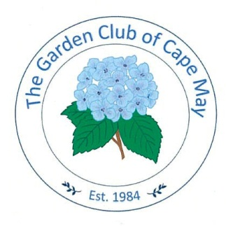

CONTACT: Susan Krysiak For Immediate Release
Director of Media Relations April 10, 2026
609-224-6036
skrysiak@capemaymac.org

Gardens of Cape May Tour and Garden Club of Cape May Flower Show team up May 16

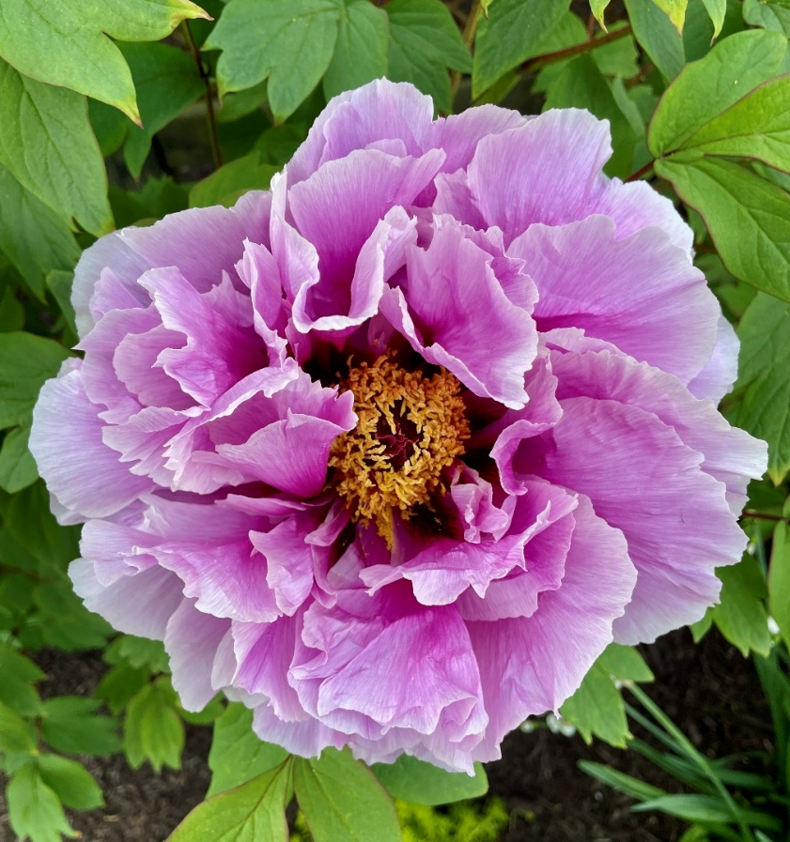
Photo courtesy of Garden Club of Cape May

CAPE MAY, N.J. – Don’t miss two of the biggest gardening events in Cape May, grafted together into one exceptional experience! Cape May MAC (Museums+Arts+Culture) and the Garden Club of Cape May partner up for this year’s Gardens of Cape May Tour, offering garden lovers an enchanting day designed to bring garden dreams to life.
Whether a seasoned gardener or a budding enthusiast, this self-guided tour of Cape May home gardens offers inspiration and fresh ideas for the home gardener. Fantasize about gardening possibilities and see, touch and smell what’s blooming at a selection of beautiful seaside homes around Cape May. Stop at Willow Creek Winery, host to the 2026 Cape May Garden Club Show, and step inside to see an explosion of floral and horticultural interpretations of this year’s theme: “The Magic of Fairy Tales.”
The Gardens of Cape May Tour and 2026 Garden Club of Cape May Flower show are Saturday, May 16. The tour is 10am-3pm and the flower show at Willow Creek Winery is 11am-3pm (with final admission about 15 minutes prior). Tickets for the tour are $40. They can be purchased in person, online at capemaymac.org, or by calling 609-884-5404.
Properties included on the tour are:
The Bowman Residence, 1080 Seashore Road
Pat has created a stunning garden that attracts pollinators of all kinds, with a special welcome to bees. Pat is an experienced apiarist who is rewarded with delicious, natural honey from the bees she shelters on her expansive property. Beyond the meadow, which was buzzing with bees, a shaded pond creates a peaceful oasis. Friendly neighbor horses were eager to meet visitors. Inside and out, Pat’s home reflects her love of nature.
The Colonial House, 653 1/2 Washington St.
The Colonial House Museum (circa 1730) is Cape May’s oldest residence. Managed by the Greater Cape May Historical Society, its garden is designed and maintained by the Garden Club of Cape May. Especially designed for the Cape May MAC garden tour, a colorful display of potted spring bulbs will decorate the porch, featuring allium, tulips, grape hyacinths, daffodils, and Summer Snowflake. The medicinal gardens include plants historically used for teas, cooking, and medicine — yarrow for digestion, chamomile for colds, sage as an antibiotic, and angelica for plague. Formerly a tavern and militia meeting spot during the Revolutionary War, the museum will open for guided tours.
The DiDonato Residence, 1352 Vermont Ave.
“The Essential Garden” is a cottage food garden and living lab, where horticultural science, creativity, permaculture and generational cultivation practices convene to produce joyful chaos amid a 52-week harvest in Growing Zone 8a. Christine DiDonato has been cultivating Cape May soil since 1980. She culls her Rutger’s Master Gardener education, her years in healthcare and research and her love of working the ground to champion local food sovereignty, to improve physical strength and mobility and to instill excitement and pride in what we grow and share with our community to nourish both our bodies and spirit. Her planting strategy employs the benefits of native flora to support biodiversity to create resilient, food producing landscapes and native habitats in harmony with nature to create a veritable food forest that feeds many, especially her dog, Stella, a dedicated taste tester. Points of focus are soil solarization, fig trees, apple trees, blueberries, strawberries, peach tree, vermicomposting, invasive species, seed saving, water conservation and composting. Christine dedicates her 2026 Garden to her mother, Eleanor.
The Emlen Physick Estate, 1048 Washington St.
Tour seven different gardens on the grounds of Cape May’s only Victorian house museum. The Oval Garden is a colorful recreation of a Physick Family Garden from historic photos. The herb garden features ornamental and culinary herbs. The Fred and Sarita Kuhner Memorial Shade Garden offers a refreshing retreat on a hot summer’s day. The Elvira Turnao Memorial Garden features a fountain, benches, and young fig trees. The Pollinator Garden focuses on a collection of native plants to attract butterflies and bees. Lastly, the newest garden, the Walter Lindheimer Memorial Garden, is a tribute garden by the Kiraly family to “Uncle Walter” who was the gardener for the Physick Family for many years.
The Lovitz Residence, 1012 Cape May Ave.
Evelyn Lovitz welcomes you to her garden, a wildlife-friendly garden comprised of trees, bushes and perennials that attract, feed and protect wildlife. Evelyn chooses to grow these plants to enjoy beautiful, hardy plants, to save time and money, to bring in birds and butterflies and to improve water quality. You will see mostly South Jersey native herbaceous plants, shrubs and trees here. The sedum (non-native) are covered in butterflies in late summer. In back on the left of the yard are water-loving shrubs. This was a very wet area when Evelyn created this bed, and now the plants address that problem, soaking up the water. There are two ponds: one is a moving pond for the birds and the other is a still pond for dragonflies.
The Olah Residence, 600 Sunset Blvd.
The most repeated comment at this property is that you’d never know the beach is half a mile away. Located on one acre on Sunset Boulevard, trees cover much of the secluded rear yard. Two small ponds and a natural vernal pond provide water for birds year-round. Wild turkeys, coyotes, fox, ducks, and migrating birds visit regularly. Plantings, mostly native, include mature oaks, maples, holly, cedar, redbud, a magnificent climbing hydrangea, Hosta, daffodil, daisy, and many more. Meandering stone paths lead you through the natural landscape.
The Orem Residence, 701 Columbia Ave.
This block of Columbia Avenue was built in the “Cottage Era” of Cape May. During World War I, the home was operated by the owner and her daughter as a tea house, with proceeds devoted to war relief. The home was painted white with red and blue accents, including flowers. Recently, the current owners had two daughters’ post-wedding brunches at the home. The landscape is traditional Victorian with roses, hydrangeas and boxwood, with mostly white (weddings) perennials and annuals. You will notice a touch of blue and light pink as well. On the garage rooftop there are two large garden boxes containing herbs and vegetables. The owner is an active member of the Garden Club of America, Darien, Conn. chapter.
The Ruzzi Residence, 1342 Vermont Ave.
This hidden gem of a garden not only includes many annuals and perennials, but also some plants not often seen in Cape May. Visitor will see the fig trees and Italian persimmons along with the full herb and vegetable garden. There is a unique Japanese fan tail willow tree that is sure to be of interest.
The Todaro-Franceschi Residence, 512 Elmira St.
A kaleidoscope of blooming color from spring until frost, the front and rear cottage gardens were created in 2005 to support wildlife. Comprised of various host plants and nectar sources — both annuals and perennials — visiting bees, butterflies, and hummers are many, as are numerous other beneficial insects, and of course, birds. In 2020 a small pond was added, which is visited by toads, birds, rabbits and even the occasional possum. A rain garden was created in 2021, with several native plants to support the environment. The gardens are pesticide-free, wildlife-certified and are also listed in the national Monarch Waystation Registry.
Willow Creek Winery, 168 Stevens St. ,
The Garden Club of Cape May Flower Show
The Garden Club of Cape May cordially invites you to attend the 2026 Flower Show, themed “Flowers & Fairytales,” at Willow Creek Winery from 11am-3pm. This event offers an excellent opportunity to enjoy lunch and explore floral displays inspired by timeless fairy tales such as Cinderella, Tinker Bell, Snow White, Rapunzel, Beauty and the Beast, and Alice in Wonderland. Horticulture exhibits will also showcase Fairy Gardens.
Cape May MAC (Museums+Arts+Culture) is a multifaceted not-for-profit organization committed to promoting the preservation, interpretation, and cultural enrichment of the Cape May region for its residents and visitors. Funding has been made possible in part by the Preserve New Jersey Historic Preservation Fund/State of New Jersey. Cape May MAC has received an operating support grant from the New Jersey Historical Commission, a division of the Department of State. Arts programs are made possible by funds from the New Jersey State Council on the Arts, a partner agency of the National Endowment for the Arts. Cape May MAC maintains and manages the 1879 Emlen Physick Estate, the 1859 Cape May Lighthouse and the 1942 World War II Lookout Tower, and is the leading organization to offer visitors tours, activities and events year-round in America’s only National Historic Landmark City. Cape May MAC membership is open to all. capemaymac.org.
The Garden Club of Cape May is dedicated to providing our members with education, resources, and opportunities to expand their love of gardening and floral design while encouraging active participation in community, environmental, and historic projects to preserve and protect our natural resources. thegardenclubofcapemay.org.

###

