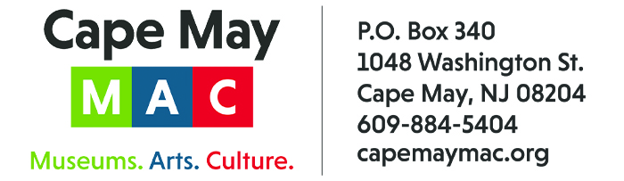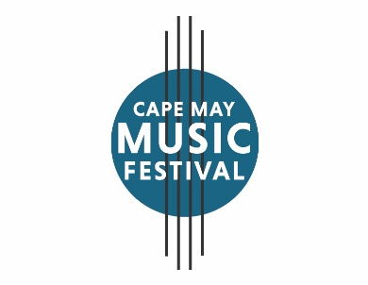

CONTACT: Susan Krysiak For Immediate Release
Director of Media Relations May 7, 2026
609-224-6036
skrysiak@capemaymac.org

The 37th Cape May Music Festival May 9-June 21 presents exciting classical, contemporary music

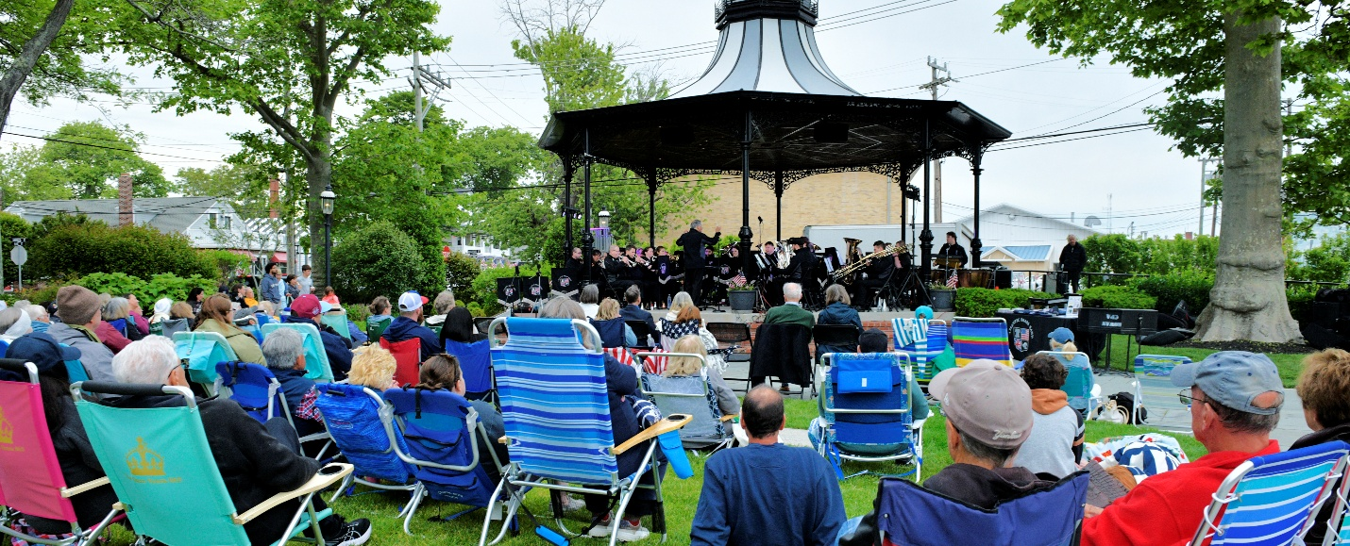

Courtesy of Cape May MAC

CAPE MAY, N.J. – For the 37th year, Cape May MAC (Museums+Arfs+Culture) presents the Cape May Music Festival, South Jersey’s premier classical music festival, which brings a seaside celebration of classical and contemporary music to Cape May, from May 9-June 21.
On Saturday, May 9 at 7 p.m. the Cape May Music Festival opens with ”Westminster Choir presents WCC@100: The Westminster Choir Looks Forward” at the Episcopal Church of the Advent, 612 Franklin St., featuring The Westminster Choir, Donald Nally, conductor, with Scott Dettra, organ. Nally is one of the nation’s leaders in the field of conducting. The Westminster Choir celebrates the college's 100th anniversary with a program featuring distinguished alumni as conductor and organist and works from the rich history of choral music. Brahms, the height of the Romantic era, and Howells, the pinnacle of the English 20th-century Renaissance, look back, while mystical minimalism is represented by its master Arvo Pärt in his iconic, Salve regina. Finally, a virtuosic contemporary work from American composer Stacy Garrop based on the writings of the “singular and iconic” Lydia Davis; an exploration of aging, told through the metaphor of decay and dissolution in a house besieged. $35 adults, $30 Cape May MAC members, $20 students.
On Sunday, May 24 at 7 p.m. the Atlantic Brass Band performs at Rotary Park, 400 Lafayette St. The internationally award-winning, 35-piece Atlantic Brass Band, under the baton of Salvatore Scarpa, returns to Cape May with an exciting new program of rousing band music, the perfect high note for this year’s Memorial Day Weekend, and the country’s 250th celebration of its founding. The concert is co-sponsored by Cape May MAC and the City of Cape May. Admission is free. In case of rain, the concert will be performed in Cape May Convention Hall, 714 Beach Ave.
On Wednesdays, June 3, 10 and 17 at 12:30 p.m. a festival favorite continues with Bach’s Lunches, at the Inn of Cape May, 7 Ocean St. Lunch and a classical music mini concert combine for a gorgeous afternoon at the historic Inn of Cape May. These intimate performances feature members of the Bay Atlantic Symphony. $55 adults, $50 Cape May MAC members.
On Thursday, June 4 at 7 p.m. Bay Atlantic Symphony presents “Song and Dance” at the Episcopal Church of the Advent, 612 Franklin St. The symphony performs Arthur Foote’s Serenade, Op. 25, Bach’s Violin Concerto in A minor with violinist Ruotao Mao, and Isaac Albeniz’s España. The center of Bach’s violin concerto is a breathtakingly lyrical middle movement with a sweeping melody of spiritual dimensions, shared between the soloist and orchestra. It is bookended by jaunty movements, the last being a gigue (jig). American composer Arthur Foote’s Serenade sings to the audience with bucolic grace and rhapsody. Albéniz’s España takes the audience on a sensual tour of picturesque regions throughout Spain. $35 adults, $30 Cape May MAC members, $20 students.
On Saturday, June 6 at 7 p.m. New York Chamber Ensemble presents “Classical Classics – Haydn, Mozart and Beethoven” at the Episcopal Church of the Advent, 612 Franklin St. Featuring Artistic Director Eliot Bailen, cello, and Susan Rotholz, flute, the New York Chamber Ensemble presents some of classical music’s notable favorites: Flute Quartet in D Major, Op. 3, No. 5, by Franz Josef Haydn, String Quartet in D Major No. 21, K. 575 by W.A. Mozart and String Quartet No. 8 in E Minor, Op. 59, No. 2 by L. van Beethoven. $30 adults, $25 Cape May MAC members, $15 students.
On Sunday, June 7 at 7 p.m. the festival presents “Wanderlust,” the 14th Annual George Mesterhazy Tribute Concert, at the Episcopal Church of the Advent, 612 Franklin St. Outstanding jazz musicians from near and far come for this once-a-year tradition that reignites joyful memories of a beloved and respected musician and friend, George Mesterhazy. Whether he knew you or just met you, George drew you in with his magnetism and talent. A renowned and distinguished jazz pianist, his generosity as a musician is legendary. He began his association with the festival in 2007 with an annual jazz concert devoted to music of the Great American Songbook, and since his passing in 2012, the festival continues his legacy. This year’s theme reflects the many ways music can transport us to so many beautiful places, both real and imaginary. $35 adults, $30 Cape May MAC members, $15 students.
On Thursday, June 11 at 7 p.m. the New York Chamber Ensemble presents “Bartok, Rachmaninoff, Dohnanyi and Stravinsky: The Genius of American Immigrant Composers,” featuring Margaret Kampmeier, piano and Alan Kay, clarinet, at the Episcopal Church of the Advent, 612 Franklin St. The New York Chamber Ensemble presents Trio Elegaique in G Minor by Rachmaninoff, Aria for Flute and Piano, Op. 48 by Dohnanyi, Histoire de Soldat for violin, clarinet and piano by Stravinsky, Suite Paysanne Hongroise for flute and piano by Bela Bartok, and Sextet, Op. 37 for clarinet, horn, strings and piano by Dohnanyi. $30 adults, $25 Cape May MAC members, $15 students.
On Friday, June 12 at 12:30 p.m. the festival presents Midday Music & More at the Washington Inn, 801 Washington St. The afternoon features a stirring classical music performance over a superb lunch at the historic Washington Inn, presented by Friends of the Cape May Music Festival, featuring Eliot Bailen, Susan Rotholz and Jed Gaylin. $60.
On Saturday, June 13 at 11 a.m. Jazz Brunch with Paula Johns at the Shore Club features festival favorite Paula Johns, the renowned singer, accomplished cabaret singer and jazz vocalist from Philadelphia, who is often compared to Ella Fitzgerald and some of the great contemporaries of that era. Savor a superb lunch in a beautiful room that overlooks lush, green open space. Paula brings her own distinctive panache to each song she sings, featuring songs from The Great American Songbook, including Porter, Rodgers & Hart, Jobim, Bacharach and others. $70.
On Thursday, June 18 at 7 p.m. the New Jersey Symphony Chamber Players at the Episcopal Church of the Advent, 612 Franklin St. Symphony members Darryl Kubian, violin, Ming Yang, violin, David Blinn, viola, and Philo Lee, cello, form a string quintet to delight audiences with String Quartet in G Major, Op. 76, No. 1 by Joseph Haydn, Strum, by Jessie Montgomery, String Quartet in C Minor, Op. 18 No. 4 by Ludwig van Beethoven, and String Quartet No. 6 in F minor, Op. 80 by Felix Mendelssohn. $30 adults, $25 Cape May MAC members, $15 students.
On Saturday, June 20 at 7 p.m. the Bay Atlantic Symphony presents "Loveletter, Lullabies, and Footstomps” at The Episcopal Church of the Advent, 612 Franklin St. Gustav Mahler’s achingly expressive Adagietto is a love letter to his wife Alma. This hauntingly famous romance leads into an equally beautiful pastorale by Aaron Copland, which turns, on a dime, into a rhythmic jazzy stomp through the streets of Copland’s native New York. The virtuosic work was written for Benny Goodman. The symphony embraces with open arms the various jaunty sounds of America in the concert’s second half with the Hoedown from Rodeo, Gershwin’s bluesy Lullaby, and fun-loving tunes by Leroy Anderson. $35 adults, $30 Cape May MAC members, $20 students.
On Sunday, June 21 at 7 p.m. New York Chamber Ensemble presents “The Music of Freedom – A Musical Celebration of the 250th,” featuring Paul Woodiel, violinist, fiddler and raconteur, and other special guests, at the Episcopal Church of the Advent, 612 Franklin St. The New York Chamber Ensemble presents a musical program with special guests to celebrate the nation’s founding fathers and its 250th anniversary — on Father’s Day! The ensemble celebrates the music of freedom and honors this decisive moment in history. $30 adults, $25 Cape May MAC members, $15 students.
Since 1990, the Cape May Music Festival has brought the only seaside celebration of classical and contemporary music to Cape May each spring. Donations help underwrite this annual gift to the Cape May community and are always appreciated. For ticket information visit capemaymac.org or call 609-884-5404. Cape May MAC (Museums+Arts+Culture) is a multifaceted not-for-profit organization committed to promoting the preservation, interpretation, and cultural enrichment of the Cape May region for its residents and visitors.
Arts programs are made possible by funds from the New Jersey State Council on the Arts, a partner agency of the National Endowment for the Arts. The 2026 Cape May Music Festival is sponsored in part by Brown & Brown of New Jersey, LLC, the David R. & Patricia D. Atkinson Foundation, Madison Resorts and the Cape May Star & Wave newspaper.
Cape May MAC maintains and manages the 1879 Emlen Physick Estate, the 1859 Cape May Lighthouse and the 1942 World War II Lookout Tower, and is the leading organization to offer visitors tours, activities and events year-round in America’s only National Historic Landmark City. Cape May MAC membership is open to all. capemaymac.org.

###

