

CONTACT: Susan Krysiak For Immediate Release
Director of Media Relations Dec. 12, 2025
609-224-6036
skrysiak@capemaymac.org

Davenport sofa in Physick House Museum restored courtesy of local Questers group

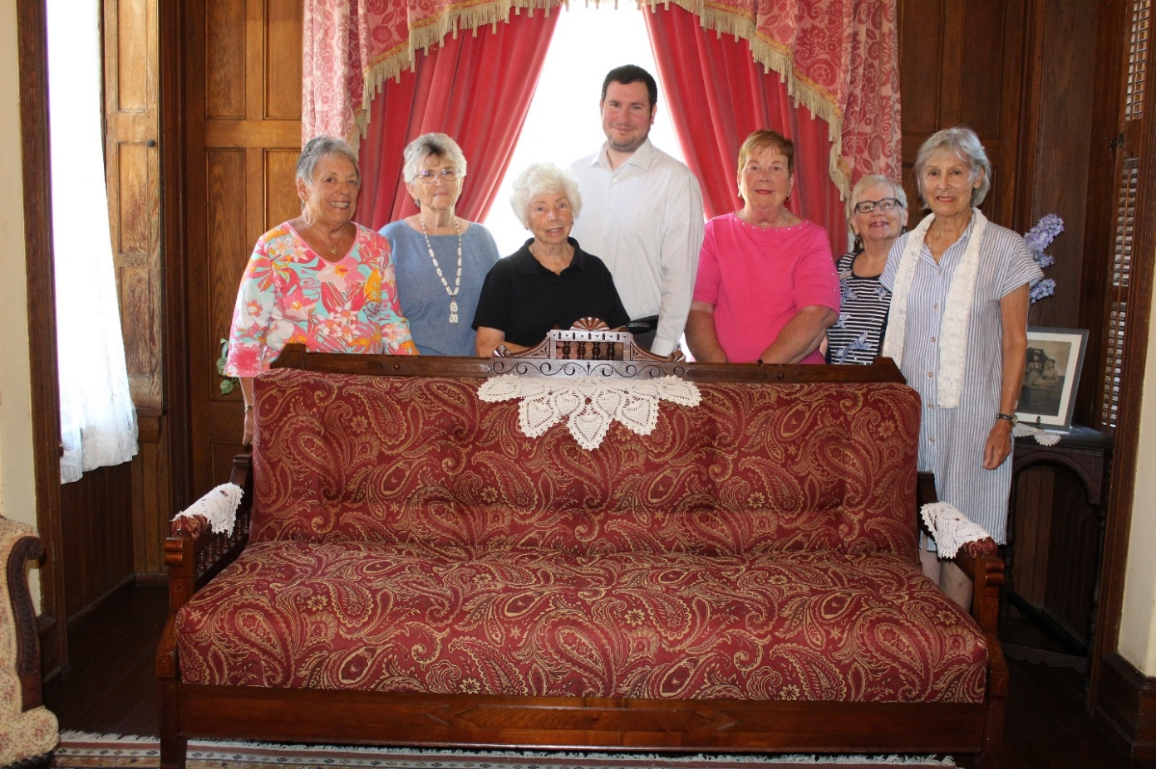

Photo Caption (Photo courtesy of Cape May MAC): Members of the Olde Cape May Lighthouse Questers with Cape May MAC Curator Ben Ridings and the newly restored davenport in its rightful place in the Physick House sitting room, from left: Yvonne Kummerle, Barbara Oberholtzer, Joyce Barth, Ridings, Mary Beth Hager, Carol Hartman, Eileen Kirk.

CAPE MAY, N.J. — The Victorian version of a futon in the sitting room of the 1879 Emlen Physick House Museum has gotten a new lease on life, thanks to members of the Olde Cape May Lighthouse Questers, a group dedicated to preserving history. Known as a “davenport,” the sofa folds out into a bed, but it is more than just a piece of furniture. This elegant artifact has traveled through time, generations, and nearly a century of stories. Its journey began around 1880, likely original to the time of the home’s completion, a proud possession of the Physick family and a fixture in their Victorian life.
After decades out of sight, the davenport made its way back to Cape May MAC (Museums+Arts+Culture) in 1980, thanks to a heartfelt donation by Julia Grinder, a close friend of Emilie Cresse. Emilie’s mother, Frances Brooks, had inherited the Physick Estate in 1935 following the death of Dr. Emlen Physick’s aunt, the last surviving member of the family line. Through these personal connections, the sofa found its way home again.
By the time it returned, time had taken its toll. The glue once holding its frame together weakened, and its upholstery was faded, brittle and fraying. Yet, there was something undeniably special about this worn-out davenport: a story waiting to be revived.
That’s when the Olde Cape May Lighthouse Questers stepped in.
Driven by a mission to preserve the past for future generations, the Questers, a passionate community of history lovers, secured funding through a state Quester grant to restore the piece. Their involvement was not just about restoring wood and fabric; it was about rekindling a piece of Cape May’s soul.
The restoration process took just three weeks, but its impact was profound. With renewed structure and carefully selected fabric, the davenport regained its dignity, once again taking its place in the historic estate.
The Questers have long been champions of preservation across Cape May, supporting numerous projects with generosity and care. Their dedication has helped breathe life back into the estate's many treasures, and their work with Cape May MAC continues to be a partnership built on respect, purpose and shared love of history.

###

Cape May MAC (Museums+Arts+Culture) is a multifaceted not-for-profit organization committed to promoting the preservation, interpretation, and cultural enrichment of the Cape May region for its residents and visitors. Funding has been made possible in part by the Preserve New Jersey Historic Preservation Fund/State of New Jersey. Cape May MAC has received an operating support grant from the New Jersey Historical Commission, a division of the Department of State. Arts programs are made possible by funds from the New Jersey State Council on the Arts, a partner agency of the National Endowment for the Arts. Cape May MAC maintains and manages the 1879 Emlen Physick Estate, the 1859 Cape May Lighthouse and the 1942 World War II Lookout Tower, and is the leading organization to offer visitors tours, activities and events year-round in America’s only National Historic Landmark City. Cape May MAC membership is open to all. capemaymac.org.

