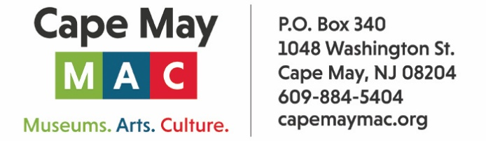

CONTACT: Susan Krysiak For Immediate Release
Director of Media Relations April 28, 2026
609-224-6036
skrysiak@capemaymac.org

‘Cape May First & Only’ Exhibit at Physick Estate marks historic city anniversaries
In partnership with the City of Cape May, two exhibits in one at the Carroll Gallery at the Physick Estate tell this city’s stories from 1851 onward
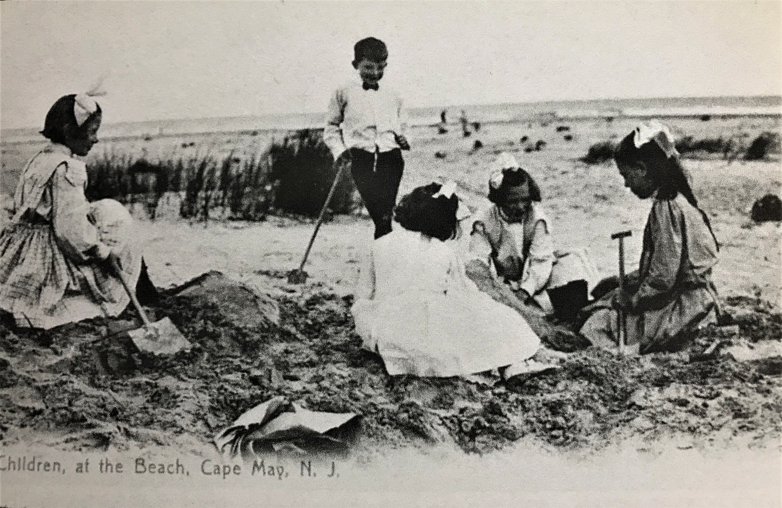
Photo courtesy of Cape May MAC archives

CAPE MAY, N.J. – As the nation celebrates its 250th anniversary, the City of Cape May also marks two significant anniversaries: the 175th anniversary of its incorporation as a city in 1851, and the 50th anniversary of its designation as a National Historic Landmark in 1976, making 2026 in Cape May an extraordinary year.
The City of Cape May is offering a variety of engaging events to mark the occasion, and Cape May MAC (Museums+Arts+Culture) has partnered with the city to present this year’s Carroll Gallery Exhibit, “Cape May: First & Only,” which celebrates these milestones with two exhibits in one location, at the Emlen Physick Estate, 1048 Washington St., where Cape May’s renaissance as a tourism destination and its profound historic preservation success story began in 1970.
Curated by Cape May MAC President Janet Coupland and Cape May MAC Curator Ben Ridings, and designed by Cape May MAC Exhibit Designer Steven Olszewski, the exhibit takes a deep look at 175 years of history in America’s First Seaside Resort, as well as the last 50 years as the nation’s only National Historic Landmark City. Cape May, the first and only, hails its unique place in 2026 as “America’s First Seaside Resort” and the nation’s only National Historic Landmark City. Just as the nation commemorates its founding, Cape May proudly reflects on its own journey, honoring its heritage while embracing a future built on the strength of community, culture, and timeless charm.
“As we celebrate 250 years of America, 175 years of Cape May City, and 50 years of our National Historic Landmark status, we are reminded that history is not just preserved in Cape May, it’s alive,” said Mayor Zack Mullock. “Through the dedication of Cape May MAC, the stories, heritage, and spirit of this extraordinary place continue to inspire all. Together, we honor our past and protect our future.”
“Cape May MAC is honored to curate this special exhibit and to host it in the Carroll Gallery at the historic 1879 Physick Estate,” said Cape May MAC Director & CEO Jody Alessandrine. “Each year from spring through late fall we mount an exhibit that is free and open to the public featuring a unique aspect of local history. This exhibit, “Cape May: First & Only,” celebrates this extraordinary year of once-in-a-lifetime milestones, and shares the joy of history that is our organization’s legacy and our mission. We look forward to sharing these stories with the public.”
The public is invited to the Carroll Gallery Exhibit Opening celebration, Friday, May 1 at 4pm at the Carroll Gallery, on the grounds of the Emlen Physick Estate, 1048 Washington St. The exhibit is open May 1-Nov. 2. In addition, two original paintings will be unveiled at the opening by renowned artist and architect Len Tantillo, one featuring the Emlen Physick Estate, and the other, Dr. Emlen Physick, himself. Len Tantillo is a graduate of the Rhode Island School of Design and a licensed architect who left the field of architecture in 1986 to pursue a career in the fine art of historical and marine painting. His work is included in the collections of the Fenimore Art Museum, the Minnesota Museum of Marine Art, numerous historical societies, and corporate and private collections in the United States and abroad. These paintings are being donated to Cape May MAC. Print copies will be available to order, with proceeds supporting the organization as part of a fundraising initiative.
For more information on the city’s celebrations, visit capemayfirstandonly.com. For more information on Cape May MAC’s tours, activities and events, visit capemaymac.org.
Cape May MAC (Museums+Arts+Culture) is a multifaceted not-for-profit organization committed to promoting the preservation, interpretation, and cultural enrichment of the Cape May region for its residents and visitors. Funding has been made possible in part by the Preserve New Jersey Historic Preservation Fund/State of New Jersey. Cape May MAC has received an operating support grant from the New Jersey Historical Commission, a division of the Department of State. Arts programs are made possible by funds from the New Jersey State Council on the Arts, a partner agency of the National Endowment for the Arts. Cape May MAC maintains and manages the 1879 Emlen Physick Estate, the 1859 Cape May Lighthouse and the 1942 World War II Lookout Tower, and is the leading organization to offer visitors tours, activities and events year-round in America’s only National Historic Landmark City. Cape May MAC membership is open to all. capemaymac.org.

