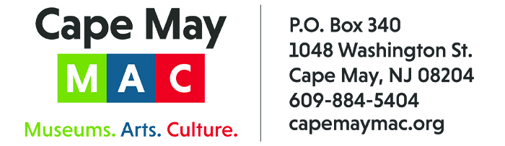

CONTACT: Susan Krysiak FOR IMMEDIATE RELEASE
Director of Media Relations Nov. 19, 2025
(609) 224-6036
skrysiak@capemaymac.org

Paul Mulligan of West Cape May is Cape May MAC Volunteer of the Month for November

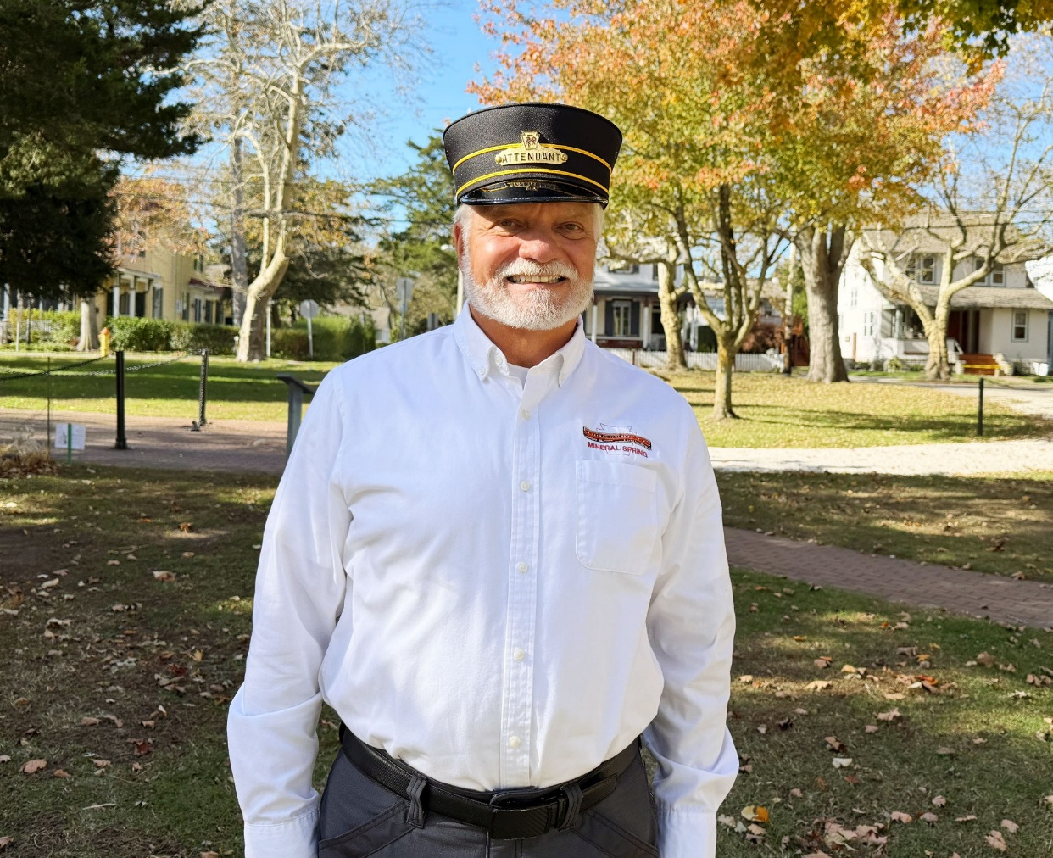

CAPE MAY - (Photo courtesy of Cape May MAC) - Cape May MAC (Museums+Arts+Culture) announces Paul Mulligan of West Cape May has been chosen as Volunteer of the Month for November. Mulligan was nominated by Cape May MAC’s Chief Outreach Strategist Mary Stewart, who selected him for presenting his fascinating Lunch & Learn talk, “Mapping Cape May’s Railroads,” on Sept. 3. Mulligan showed an appreciative audience how railroad lines in Cape May underwent many changes, from the beginning of the railroad era through their decline. Mulligan is a published local railroad historian. He used mapping to reveal the story of railroads in Cape May, showing the diversity of trains that served the city - mainline, trolley, industrial and military. “We really appreciate Paul taking the time to share his vast knowledge and passion for railroads with our Lunch & Learn audience,” Stewart said. “The audience captured his enthusiasm for the topic and that’s exactly what we aim for with our ongoing Lunch & Learn series.” For information about volunteer opportunities at Cape May MAC, contact Volunteer Coordinator Maria Amin at 609-224-6029 or mamin@capemaymac.org. Cape May MAC is a multifaceted not-for-profit organization committed to promoting the preservation, interpretation and cultural enrichment of the Cape May region for its residents and visitors. Cape May MAC membership is open to all. For information about the year-round schedule of tours, festivals and events, visit capemaymac.org.

###

