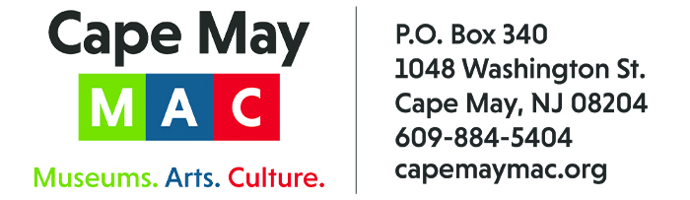

CONTACT: Susan Krysiak FOR IMMEDIATE RELEASE
Director of Media Relations Feb. 13, 2026
(609) 224-6036
skrysiak@capemaymac.org

Gerri and Chris Ridings are Cape May MAC Volunteers of the Month for February

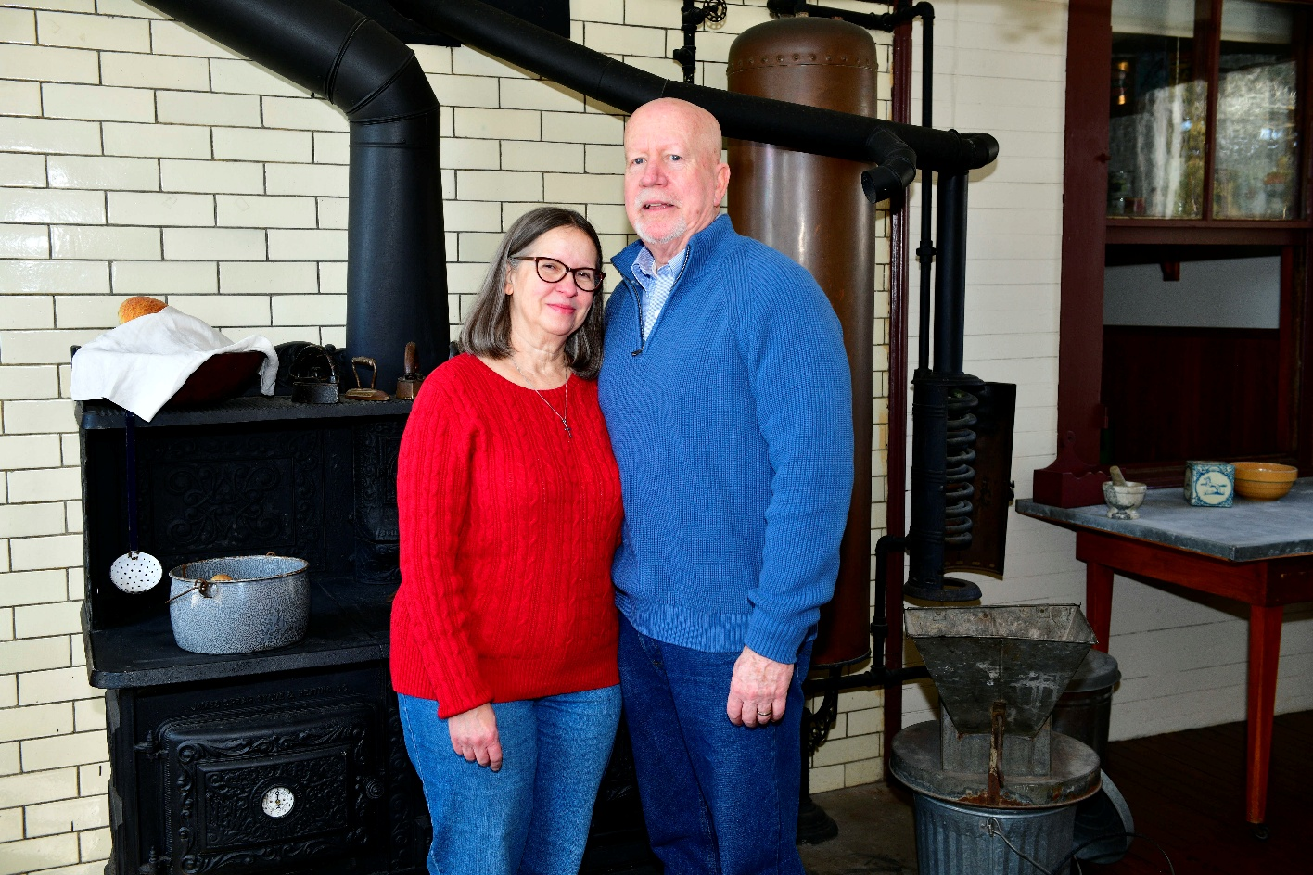

CAPE MAY - (Photo courtesy of Cape May MAC) – Shown here in the kitchen of the Physick House Museum, 1048 Washington St., Gerri and Chris Ridings are Cape May MAC (Museums+Arts+Culture) Volunteers of the Month for February. They were nominated for the honor by the nonprofit cultural and tourism organization’s Volunteer Coordinator Maria Amin. “Gerri and Chris have been steady volunteers for years,” she said. “Not only were they a tremendous help in December in decorating the Physick House museum for the holidays, but they were enthusiastic assistants in the much less festive but necessary task of taking the holiday decor down. We really appreciate how they champion the organization, and are ready to pitch in, especially at times when we are most in need of help. We thank them for their generous and consistent support.” For information about volunteer opportunities at Cape May MAC, contact Volunteer Coordinator Maria Amin at 609-224-6029 or mamin@capemaymac.org. Cape May MAC is a multifaceted not-for-profit organization committed to promoting the preservation, interpretation and cultural enrichment of the Cape May region for its residents and visitors. Cape May MAC membership is open to all. For information about a year-round schedule of tours, festivals and events, visit capemaymac.org.

###

