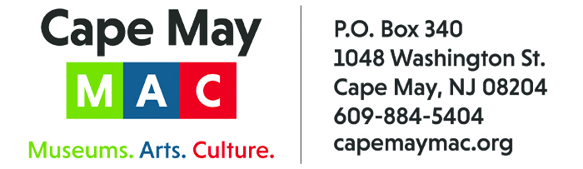

CONTACT: Susan Krysiak FOR IMMEDIATE RELEASE
Director of Media Relations May 20, 2026
(609) 224-6036
skrysiak@capemaymac.org

Bob Elwell is Volunteer of the Month for May

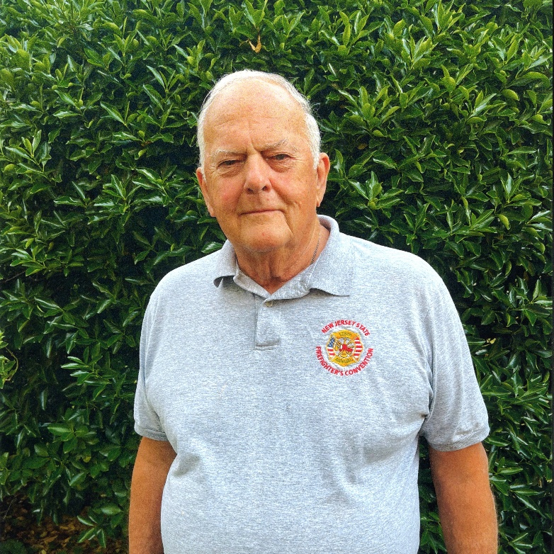

CAPE MAY - (Photo courtesy of Cape May MAC) – Bob Elwell, of Cape May, is Cape May MAC’s (Museums+Arts+Culture) Volunteer of the Month for May. He was nominated for the honor by Cape May MAC Board President Janet Coupland. “Bob is an amazing Cape May historian and was extremely instrumental in helping to develop our 2026 exhibits which celebrate the 175th anniversary of the incorporation of Cape May City, and the 50th anniversary of Cape May’s National Historic Landmark,” she said. “Bob contributed his time to the exhibit team and provided unique and invaluable historical research, articles, photos and memorabilia for the exhibits. As a former mayor of Cape May, and lifelong Cape May resident, Bob’s ongoing support of our mission is truly appreciated by all of us at Cape May MAC.” For information about volunteer opportunities at Cape May MAC, contact Volunteer Coordinator Maria Amin at 609-224-6029 or mamin@capemaymac.org. Cape May MAC is a multifaceted not-for-profit organization committed to promoting the preservation, interpretation and cultural enrichment of the Cape May region for its residents and visitors. Cape May MAC membership is open to all. For information about a year-round schedule of tours, festivals and events, visit capemaymac.org.

