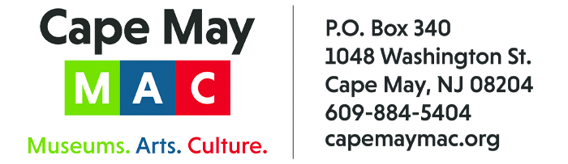

CONTACT: Susan Krysiak FOR IMMEDIATE RELEASE
Director of Media Relations June 30, 2026
(609) 224-6036
skrysiak@capemaymac.org

Hannah Vaught-Crumbock is Cape May MAC Volunteer of the Month for June

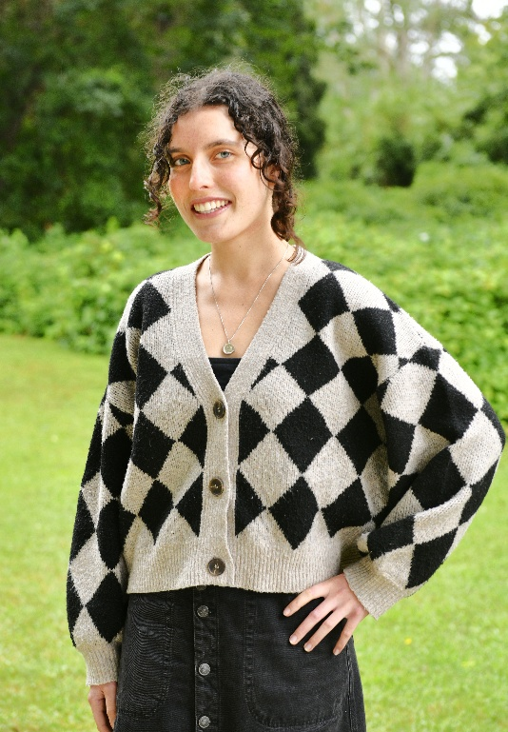
CAPE MAY - (Photo courtesy of Cape May MAC) - Cape May MAC (Museums+Arts+Culture) announces the Volunteer of the Month for June is Hannah Vaught-Crumbock of Del Haven. She was nominated by Cape May MAC Chief Outreach Strategist Mary Stewart. “Hannah has occasionally helped us with the technical production of Lunch & Learn programs,” said Stewart. “After observing our presenters, she volunteered to put together a program for April Fool’s Day. Developing a Lunch & Learn program is challenging, involving researching a topic and identifying images that help tell your story. Hannah, our youngest presenter to date, is getting ready to move on from Atlantic Cape Community College to new academic challenges and has set herself the goal of improving her public speaking and presentation skills. She named her program “Spectrums of Folly: Recounting the Archetypal Fool,” and researched the role and importance of the fool/jester in society, from ancient China through India and Europe to our contemporary world. Hannah located a variety of vintage images that illustrated the traits of fools over time. Hannah had her audience engaged and handled a lively question and answer period well. We can’t wait till she returns with a new topic.” For information about volunteer opportunities at Cape May MAC, contact Volunteer Coordinator Maria Amin at 609-224-6029 or mamin@capemaymac.org. Cape May MAC is a multifaceted not-for-profit organization committed to promoting the preservation, interpretation and cultural enrichment of the Cape May region for its residents and visitors. Cape May MAC membership is open to all. For information about the year-round schedule of tours, festivals and events, visit capemaymac.org.
###

