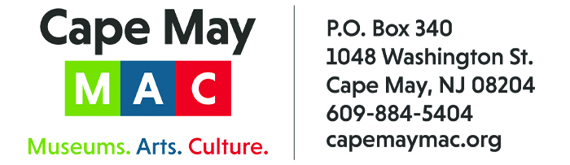

CONTACT: Susan Krysiak For Immediate Release
Director of Media Relations Sept. 11, 2026
609-224-6036
skrysiak@capemaymac.org

Craft beers, music, food trucks, family fun at the Physick Estate during Harvest Brew Fest Sept. 19

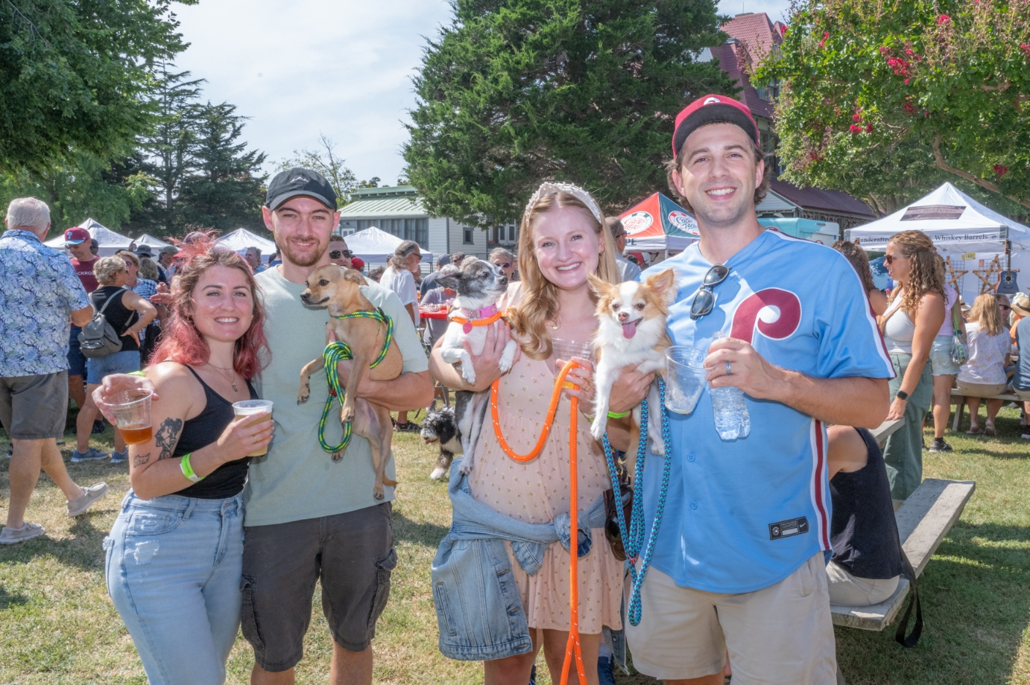
Photo courtesy of Cape May MAC
This year’s Harvest Brew Fest on the grounds of the Emlen Physick Estate is Saturday, Sept. 19 from 10 a.m. to 5 p.m.

CAPE MAY, N.J. – Celebrate the arrival of fall in South Jersey during Harvest Brew Fest, Saturday, Sept. 19 from 10 a.m. to 5 p.m., a full day of celebration and relaxation at summer’s end! Presented by Cape May MAC (Museums+Arts+Culture) and sponsored by PNC Bank, Madison Resorts, Surfside and Tito’s Vodka, it’s all at the beautiful grounds of the Emlen Physick Estate, 1048 Washington St.
Enjoy craft beers and more during this all-day festival that features local food vendors, local artisans, local breweries and local musical talent. Admission to the grounds is free. Proceeds support Cape May MAC’s free educational outreach initiatives offered to learners of all ages.
Relax and listen to live music on the outdoor stage. Bring a lawn chair or spread out your beach blanket in the shade for a great afternoon of outstanding musical performers. Animal House plays from 11 a.m. to 2 p.m. Fat Mezz takes the stage from 2:15 p.m. to 5 p.m.
Food vendors will be available and include Bake’n Bacon, Boy Scouts Concession Stand, Greens & Grains, House of Cupcakes, Rollin Bone, Matt’s Family Taste the Love, Southern State Oyster, Kreations by Kate, and Sweet Dreams Ice Cream.
Beverage vendors include Anglesea Aleworks, Behr Brewing, Cape May Brewing Co., MudHen Brewing Company, Wanderback Brewery, Whale Tale Brewery, Ludlam Island Brewery and Surfside.
Bring the entire family to enjoy kid-friendly activities including lawn games and circus performers.
Pirate Pete’s Soda Pop will serve non-alcoholic soda. A cooling off tent for pets will be available. Explore the variety of crafts and collectibles vendors on the estate grounds selling handmade and vintage items. Well-behaved dogs are welcome.
Free parking is available off site at the Cape May Elementary School, 921 Lafayette St. A free trolley shuttle will operate from the Washington Street Mall Information Booth at Ocean Street to the estate throughout the day. Admission to the grounds is free and food, beverages and other items are available for purchase. A valid ID is required for age identification to purchase alcoholic drinks.
For more information visit https://capemaymac.org/eat-drink/harvest-brew-festival/.
Cape May MAC (Museums+Arts+Culture) is a multifaceted, not-for-profit organization committed to promoting the preservation, interpretation and cultural enrichment of the Cape May region for its residents and visitors. Cape May MAC membership is open to all. Visit capemaymac.org/support/membership to learn more. For information about Cape May MAC’s year-round schedule of tours, festivals and special events, visit capemaymac.org. For information about historic accommodations, contact Cape May Historic Accommodations at capemaylodging.com. For information about restaurants, accommodations and shopping, call the Chamber of Commerce of Greater Cape May at 609-884-5508. Cape May MAC is committed to making its programs accessible to as many individuals as possible. If you require assistance, please call 609-884-5404 in advance so we may accommodate you. New Jersey Relay Center for TTY customers, please call 711 (800-852-7899).

###

