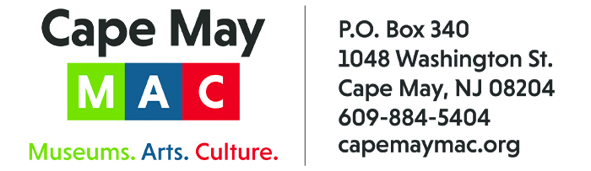

CONTACT: Susan Krysiak For Immediate Release
Director of Media Relations Oct. 6, 2026
609-224-6036
skrysiak@capemaymac.org

Cape May celebrates its Victorian era with tours and events during Victorian Weekend Oct. 9-12

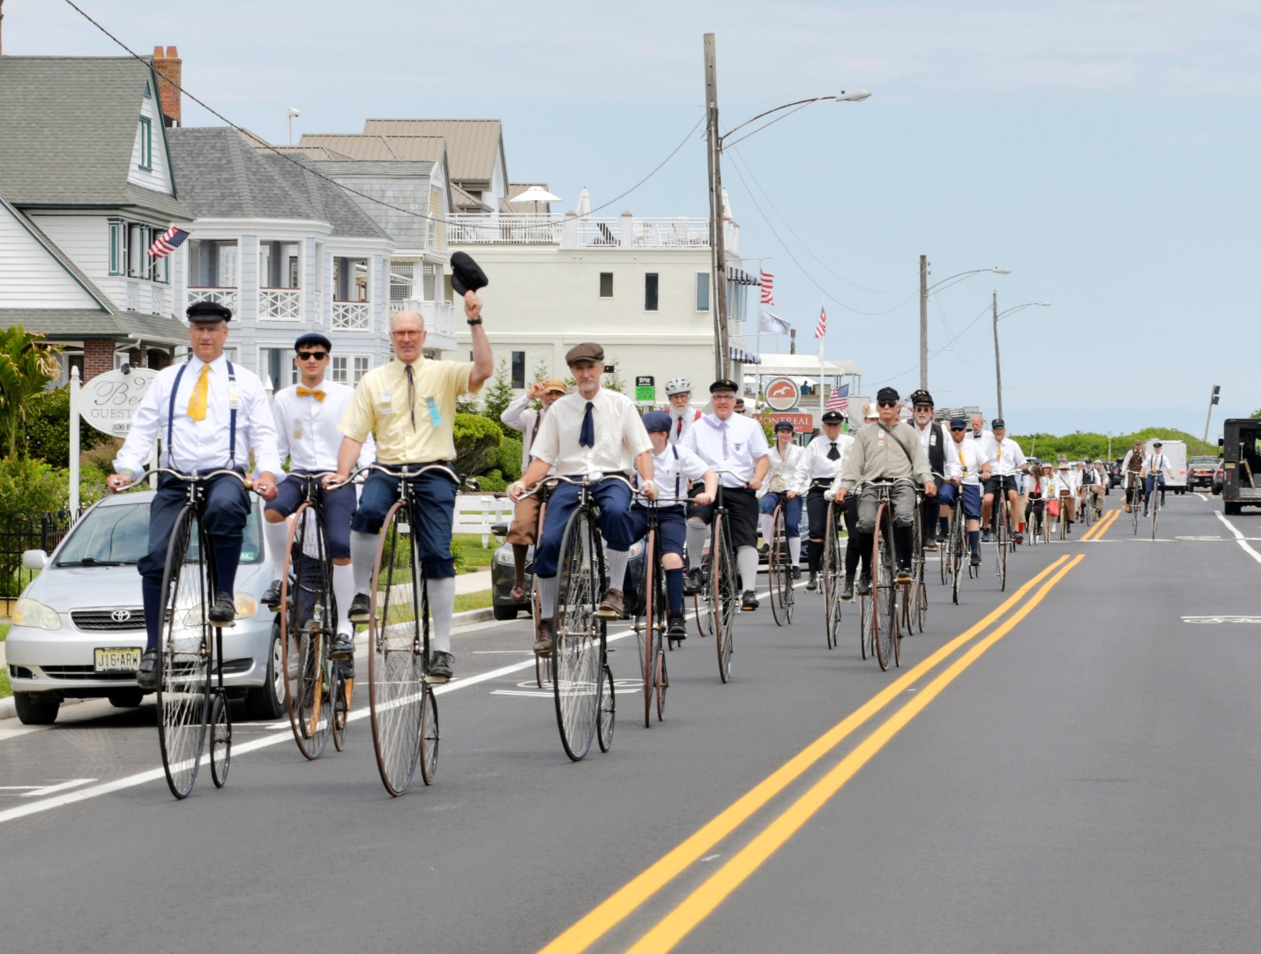
Photo courtesy of Cape May MAC/The Wheelmen will be at the Physick Estate Sunday, Oct. 11, 10 a.m. to 4 p.m.

CAPE MAY — Cape May’s 54th annual Victorian Weekend, presented by Cape May MAC (Museums+Arts+Culture), celebrates the city’s famous Victorian architecture and history with a holiday weekend of house tours, walking tours, a vintage “base ball” game, a crafts and collectibles show, murder mystery dinner, trolley tours and more, from Friday, Oct. 9 through Monday, Oct. 12.
Don’t miss this year’s vintage “base ball” game Saturday, Oct. 10 at 11 a.m. at Lafayette Field, played with late 1800s rules. Expand your knowledge of history with the 14th annual Lessons of History Distinguished Lecture Series Sunday, Oct. 11 at 5 p.m., welcoming Susan Eisenhower, granddaughter to President Dwight D. “Ike” Eisenhower, to present “Contemporary Ike: The Art of Strategic Decision Making.” Step inside Victorian homes and properties on the Victorian Weekend Historic House Tour, take a walk along historic streets on the Victorian Weekend Architectural Walking Tour, explore makers’ crafts at the annual Victorian Weekend Crafts & Collectibles Show Sunday, Oct. 11 from 10 a.m. to 4 p.m., and watch the Wheelmen take to their penny farthings, or high wheelers. Plus, there are more trolley tours, house tours and historic sites to explore. Visit here for more information: https://capemaymac.org/experience/special-events/victorian-weekend/
Tour tickets may be purchased in advance by phone at 609-884-5404, online at capemaymac.org or in person by visiting Hill House Visitor Service Center or Carriage House Visitor Service Center, both at the Emlen Physick Estate, 1048 Washington St., or the Washington Street Mall Information Booth at Washington Street at Ocean Street. Cape May MAC is committed to making its programs accessible to as many individuals as possible.
Cape May MAC (Museums+Arts+Culture) is a multifaceted not-for-profit organization committed to promoting the preservation, interpretation, and cultural enrichment of the Cape May region for its residents and visitors. Funding has been made possible in part by the Preserve New Jersey Historic Preservation Fund/State of New Jersey. Cape May MAC has received an operating support grant from the New Jersey Historical Commission, a division of the Department of State. Arts programs are made possible by funds from the New Jersey State Council on the Arts, a partner agency of the National Endowment for the Arts. Cape May MAC maintains and manages the 1879 Emlen Physick Estate, the 1859 Cape May Lighthouse and the 1942 World War II Lookout Tower, and is the leading organization to offer visitors tours, activities and events year-round in America’s only National Historic Landmark City. Cape May MAC membership is open to all. capemaymac.org.

