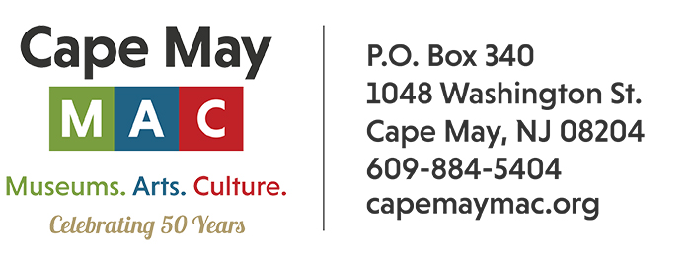
CONTACT: Susan Krysiak FOR IMMEDIATE RELEASE
Director of Media Relations June 29, 2026
(609) 224-6036
skrysiak@capemaymac.org

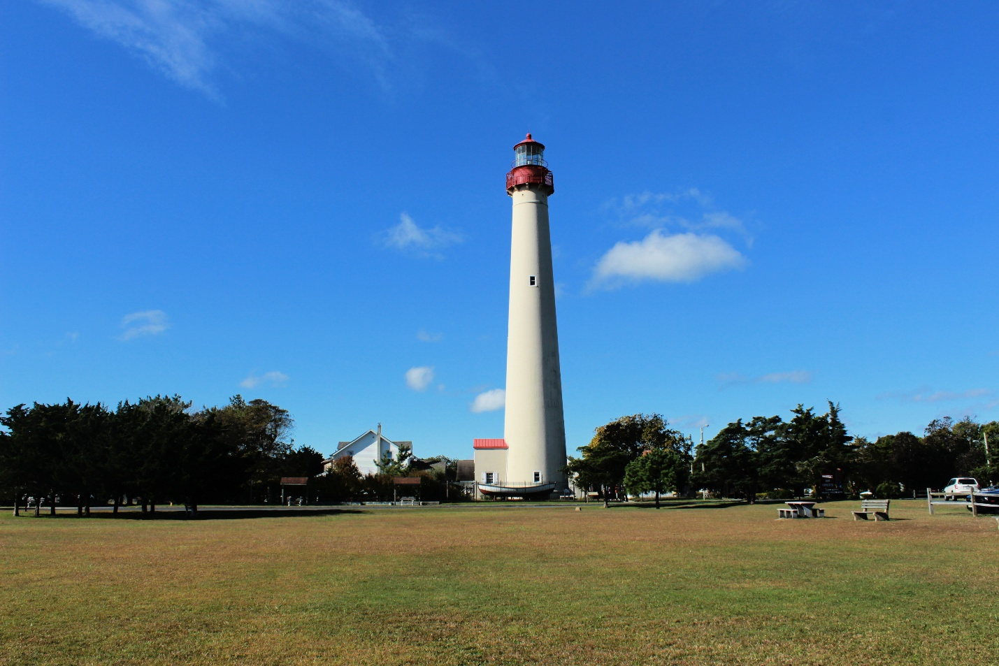
Photo courtesy of Cape May MAC

Celebrate National Lighthouse Day August 7

(June 29, 2026) CAPE MAY - Celebrate the majestic beacons that are America’s maritime treasures — lighthouses — during National Lighthouse Day at the Cape May Lighthouse on Friday, Aug. 7. Enjoy special family-friendly activities from 9 a.m. to 2 p.m., along with free climbs for children ages 3-12.
An aid to navigation since 1859 and one of the oldest continually operating lighthouses in the United States, the historic Cape May Lighthouse is hosting a day of family-friendly activities and a crafts show at the base of the lighthouse, presented by Cape May MAC (Museums+Arts+Culture).
The Cape May Lighthouse is located at 215 Lighthouse Avenue, in Cape May Point State Park, Lower Township (entrance is via Cape May Point).
Congress designated National Lighthouse Day on Aug. 7, 1989, marking the 200th anniversary of the signing of the Lighthouse Act and the commissioning of the first federal lighthouse in the United States. The purpose was to provide recognition for the important role that lighthouses have played in the history of this country, and the values of safety, heroism, and American ingenuity that they represent, as well as honoring and encouraging continued restoration efforts for existing lighthouses, many of which had fallen into disrepair.
In 1857, the Army Corps of Engineers began construction of the Cape May Lighthouse and the beacon was first lit on October 31, 1859. By the 1980s, because of limited federal funds, the Coast Guard began to lease lighthouses around the country to groups willing to maintain and restore the structures. In 1983, Cape May MAC, a Cape May leader in historic preservation, expressed interest in restoring the Cape May Lighthouse to its original condition. In December 1986, the Coast Guard leased the tower to the New Jersey Department of Environmental Protection’s (DEP) Division of Parks and Forestry. Cape May MAC, in turn, subleased the lighthouse from the State of New Jersey, with the mission of restoring, maintaining, and opening the structure to the public. Cape May MAC opened the ground floor to the public on July 18, 1987, and the full tower on May 28, 1988. With an annual visitation of over 79,000 people a year who pay to climb (and perhaps as many more who visit the lighthouse and grounds without climbing), the Cape May Lighthouse is one of the most popular attractions on the Jersey Cape. More than 3 million visitors have climbed the 199 steps to the top since May 1988. Cape May MAC has invested $3 million in capital improvements and tens of thousands in annual maintenance to keep the tower strong for generations to come.
Cape May MAC (Museums+Arts+Culture) is a multifaceted, not-for-profit organization committed to promoting the preservation, interpretation, and cultural enrichment of the Cape May region for its residents and visitors. Cape May MAC membership is open to all. For information about Cape May MAC’s year-round schedule of tours, festivals, and special events call 609-884-5404 or visit capemaymac.org.

