

CONTACT: Susan Krysiak For Immediate Release
Director of Media Relations July 17, 2026
609-224-6036
skrysiak@capemaymac.org

Cape May MAC unveils new stories of Cape May ghosts for those enthralled with the supernatural
Tours in 2026 bring to light new tales uncovered and discovered by the very locals who have deep connections to this seaside resort 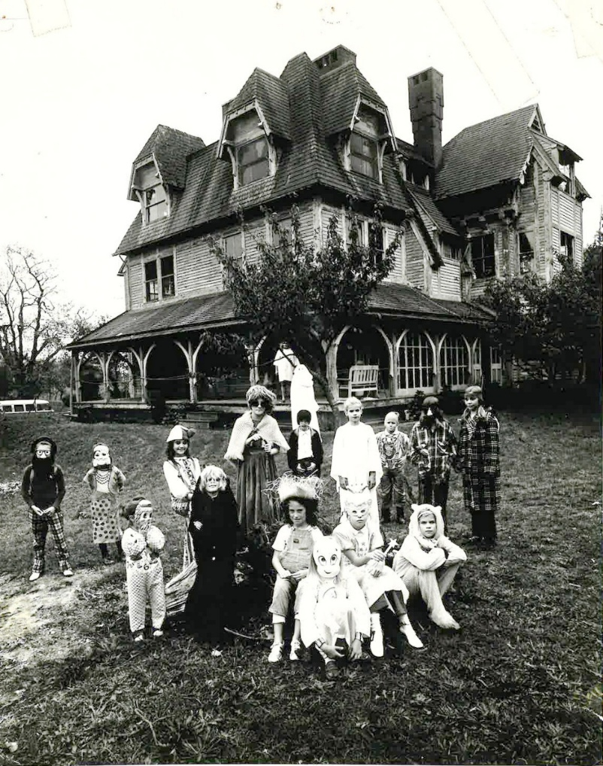
Photos courtesy of Cape May MAC

Shown here, left, the 1879 Emlen Physick Estate before it was restored, during its first fundraiser in October 1970, a “haunted house,” organized by volunteers to save the mansion from demolition. Above, the Physick House today, fully restored for years and maintained by Cape May MAC, with guided house tours and ghost tours. Cape May MAC offers the only ghost trolley tours and Physick House tours in Cape May and has been telling these stories to devoted fans since the early 2000s. This year, new stories will be featured on the trolleys.

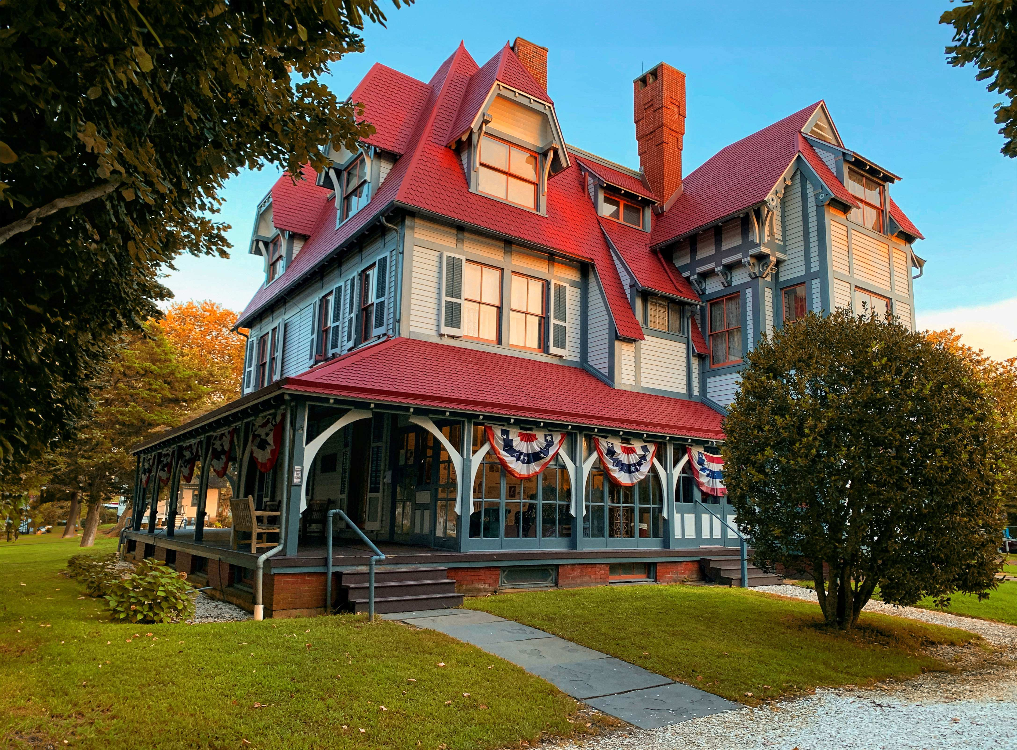
CAPE MAY, N.J. – In October 1970, with permission from the property owners-developers, close to 1,000 people came to the 1879 Emlen Physick Estate, 1048 Washington St., and stepped inside the derelict mansion, known then by locals as Cape May’s “haunted house.” The mansion was stripped for demolition and stood unpainted for decades. This haunted house fundraiser raised much-needed funds to help save the mansion from demolition. The volunteers who organized it became the core of the non-profit organization that took over the management, restoration and curation of the house, and other historic sites in Cape May, which continues today, 56 years later: Cape May MAC (Museums+Arts+Culture). The Physick House Museum is the best example of Stick Style architecture in the nation, and the crowning jewel of restoration in the only National Historic Landmark city in the nation. Still, the house has never lost its reputation as Cape May’s “original haunted house,” even as it has been beautifully and lovingly restored as Cape May’s Victorian house museum. And for good reason.
Welcome to Cape May, one of America’s most haunted seaside destinations, where the past is very much alive. With its grand Victorian homes and eerie charm, it's no surprise the spirits have decided to stay. The 1879 Emlen Physick Estate — identified as not only the prettiest building in New Jersey by Angi.com based on TripAdvisor reviews, but also the most haunted house in New Jersey — has hosted paranormal investigators, television crews, and psychic mediums on many occasions. Cape May MAC staff members, themselves, use technology to unearth the sounds that are beyond our hearing, and the visual phenomena of long-ago residents and visitors. Many staff have their own personal stories of unexplained experiences in the house.
Anyone who is interested in ghosts and hauntings in Cape May knows that medium Craig McManus is the expert on all things paranormal in America’s oldest seaside resort. McManus has been researching and using his extraordinary ability to investigate ghosts and hauntings in Cape May for the past 30 years. Cape May, America’s original seaside resort, is known as a paranormal hot spot. Ghosts are so prevalent in town, McManus has said, that they are the stuff of five books he has authored. If it haunts here, he has most likely investigated and written about it. Cape May MAC has partnered with him since 2004, sharing his stories on trolley tours and house tours. Cape May has a very special, positive energy, he has said.
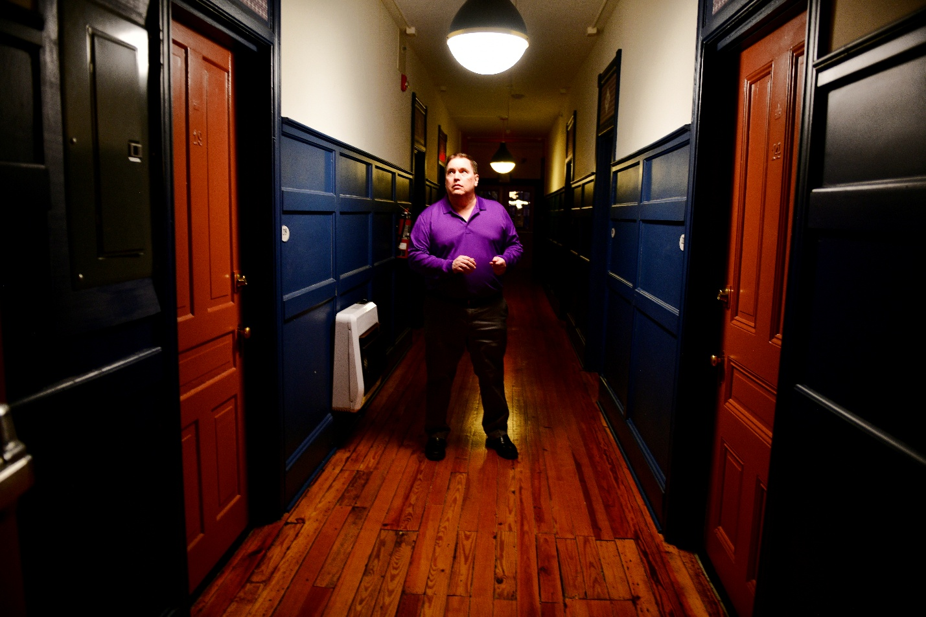
Photo by Susan Krysiak courtesy of Cape May MAC

While he resides in Bergen County, New Jersey, he considers Cape May his second home, visiting often to write, lecture and host special events.
“When I lecture about ghosts and hauntings, there is no better classroom than Cape May,” he said. “It represents every type of haunting imaginable.”
Craig McManus has been featured in New York Daily News, The New York Times, The Philadelphia Inquirer, Press of Atlantic City, The Star Ledger, NJ.com, The Record, (201) Magazine, New Jersey Monthly magazine and Martha Stewart Living magazine. He has also appeared on various television segments including the Haunted Towns series on Destination America, and the TODAY show.
Today, his work can be heard during Cape May MAC’s Ghosts of Cape May Trolley Tour, and in person during the Ghost Walk with Craig McManus and Cape May MAC’s extremely popular Channeling Dinner with Craig McManus.
Cape May’s longest-running ghost tours and experiences are presented by Cape May MAC from March through December, not just in summer. Included here are intriguing tours that delve into ghosts, magic and Victorian Spiritualism, or that provide interactive experiences inside the historic 1879 Emlen Physick Estate:
Channeling Dinner with Psychic Medium Craig McManus
Enjoy a three-course prix fixe dinner at the Inn of Cape May followed by a two-hour channeling session with Medium Craig McManus. McManus will read the energies in the room and channel messages from the spirits of departed family and friends. While he does not read everyone present and cannot control where messages come through, he will bring through as many messages from spirits as possible during the two-hour channeling. Inn of Cape May, 7 Ocean St. This event is not recommended for people under the age of 16. No refunds within 14 days of the event please. Tickets often sell out. Find out more https://cmmac.ticketapp.org/portal/product/216/events
Ghost Walk with Craig McManus
Don’t miss the only ghost walking tour in Cape May led by a renowned psychic medium! Meet the extraordinary, celebrated psychic medium and author Craig McManus as he leads you along the haunted streets of historic Cape May. The conduit for many of Cape May’s most legendary ghost stories, Craig McManus has investigated Cape May for decades and sensed very specific spirit presences here, telling these stories in his five books, and in the national media. See Craig in action and hear him describe his encounters at Cape May’s infamous paranormal hot spots. This tour leaves from the Washington Street Mall. Find out more https://cmmac.ticketapp.org/portal/product/80/events
Ghosts of Cape May Trolley Tour
Cape May, surrounded by water with well-preserved Victorian architecture, is one of the most active ghost towns in America, making the presence of ghosts here a "natural" unnatural phenomenon. This is the best ghost tour on the island, telling stories of hauntings and unexplained happenings brought to light by the uniquely gifted paranormal expert and Cape May devotee, psychic medium Craig McManus. Don’t leave town without experiencing this quintessential Cape May experience that actress Tina Fey and thousands more are talking about. This tour begins and ends at the Ocean Street Trolley Stop. Find out more https://cmmac.ticketapp.org/portal/product/12
Voices from Beyond
Don’t miss the only tour in Cape May to share actual recorded audio and visual phenomena of unexplained presences at Cape May’s very own “haunted house,” the 1879 Emlen Physick Estate. Cape May MAC staff have nurtured relationships with the home’s spirit residents for years, using paranormal research equipment to capture dozens of recordings. In Voices from Beyond, guests learn about the history and tools of paranormal research. They hear and see astonishing electronic voice phenomena (EVPs) and photographs of ghostly presences inside the renowned Physick House. Visitors are forced to reassess the line between the living and the dead. Find out more https://cmmac.ticketapp.org/portal/product/225
Haunted Tales of the Cape Combo Tour
Take an evening trolley ride through the Historic District and hear the latest stories of haunted Cape May unearthed by the very locals who have relationships with the spirit world, including those who have worked at the 1879 Physick House Museum for years. Then, step off the trolley at the museum with your guide. Learn about Victorian Spiritualism and explore Victorian methods and the objects they used to contact the spirit world as you tour select rooms. You’ll hear a story or two about unexplained happenings in the house, widely reputed to be haunted. This tour begins and ends at the Ocean Street Trolley Stop. Find out more https://cmmac.ticketapp.org/portal/product/165
Haunted Tales of the Cape Trolley Tour & Dessert at Vintage
Take an evening trolley ride through the Historic District and hear the latest stories of haunted Cape May unearthed by the very locals who have relationships with the spirit world, including those who have worked at the 1879 Physick House Museum for years. Then, step off the trolley at the Emlen Physick Estate and be seated at the renowned Vintage Restaurant, where you’ll enjoy a delicious dessert and have time to talk about your experience. A trolley shuttle will return guests to the Ocean Street Trolley Stop. Find out more https://cmmac.ticketapp.org/portal/product/13
Strange Victorian Obsessions House Tour
Victorians were fascinated with mystery and illusion and this tour through first floor rooms in the 1879 Physick House Museum shares that fascination. Learn about the famous Harry Houdini who captivated Victorian audiences with his intricate escapes, the Goddess of Mystery, Ionia, a Belgian beauty who Victorians worshipped for her spectacles of magic, The Great Lafayette, who became known as the world’s greatest magician, and Pepper’s Ghost, an illusion still used today, with Sherlock Holmes, Jack the Ripper and more. Find out more https://cmmac.ticketapp.org/portal/product/10
Spirits & Oddities Trolley Tour
Cats in ghostly form purr from the beyond. Beloved family members in photographs without their heads. Graves equipped with a torpedo to put off intruders. Victorians of the late 19th century had wild notions about the passage from life to death. Belief in ghosts and spirits was common and superstition abounded. Hear strange stories from Victorian Cape May history that are macabre, mysterious or just plain weird! Begins and ends at the Ocean Street Trolley Stop. Find out more https://cmmac.ticketapp.org/portal/product/15
Spirits, Oddities & Obsessions Combo Tour
Victorians of the late 19th century had wild notions about the passage from life to death and were fascinated by mystery and illusion. Board a Cape May MAC trolley and travel through the lovely Cape May Historic District. You’ll hear strange stories from Victorian Cape May history that are macabre, mysterious or just plain weird. The trolley stops at the 1879 Physick House Museum where you'll visit select rooms and learn about the famous Harry Houdini who captivated Victorian audiences with his intricate escapes, Ionia, a Belgian beauty called the Goddess of Mystery, who Victorians adored for her spectacles of magic, and many more famous Victorian masters and mistresses of illusion. Tour begins & ends at the Washington Street Mall Trolley Stop. Must be purchased together. Find out more https://cmmac.ticketapp.org/portal/product/219
Clueless at The Physick Estate: Liberty and Justice
The bond between two sisters is pushed to the limits over a major disagreement. They attempt to put aside their differences for a family Independence Day celebration, but that is quickly proven to be impossible. When someone takes things too far, will justice prevail? Everyone is suspect during Clueless at the Physick Estate, a “whodunit” similar to the popular board game. Encounter characters inside the 1879 Emlen Physick Estate, 1048 Washington St., and listen for clues as this original mystery unfolds from room to room. This tour is accessible with advance notice Find out more https://cmmac.ticketapp.org/portal/product/19
Some tours, activities and events sell out or admissions are limited. For schedules and further information, call 609-884-5404 or visit https://capemaymac.org/ghosts-mysteries/

Cape May MAC (Museums+Arts+Culture) is a multifaceted not-for-profit organization committed to promoting the preservation, interpretation, and cultural enrichment of the Cape May region for its residents and visitors. Funding has been made possible in part by the Preserve New Jersey Historic Preservation Fund/State of New Jersey. Cape May MAC has received an operating support grant from the New Jersey Historical Commission, a division of the Department of State. Arts programs are made possible by funds from the New Jersey State Council on the Arts, a partner agency of the National Endowment for the Arts. Cape May MAC maintains and manages the 1879 Emlen Physick Estate, the 1859 Cape May Lighthouse and the 1942 World War II Lookout Tower, and is the leading organization to offer visitors tours, activities and events year-round in America’s only National Historic Landmark City. Cape May MAC membership is open to all. For information about Cape May MAC’s year-round schedule of tours, festivals and events, visit capemaymac.org or call 609-884-5404.
###

Note to editors/sources:
Prettiest Building in NJ: https://www.angi.com/articles/most-beautiful-buildings-in-the-world.htm
Most Haunted: https://www.ranker.com/list/haunted-houses-by-state/jodi-smith
Tina Fey: https://www.youtube.com/watch?v=TT9cdSMW8HI

