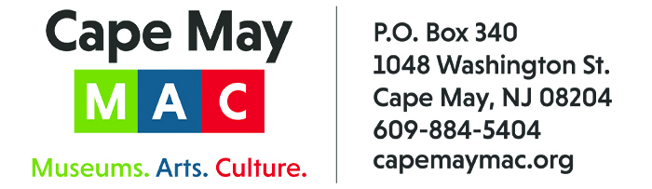

CONTACT: Susan Krysiak FOR IMMEDIATE RELEASE
Director of Media Relations July 14, 2026
(609) 224-6036
skrysiak@capemaymac.org

Janis Washington White is Cape May MAC Volunteer of the Month for July

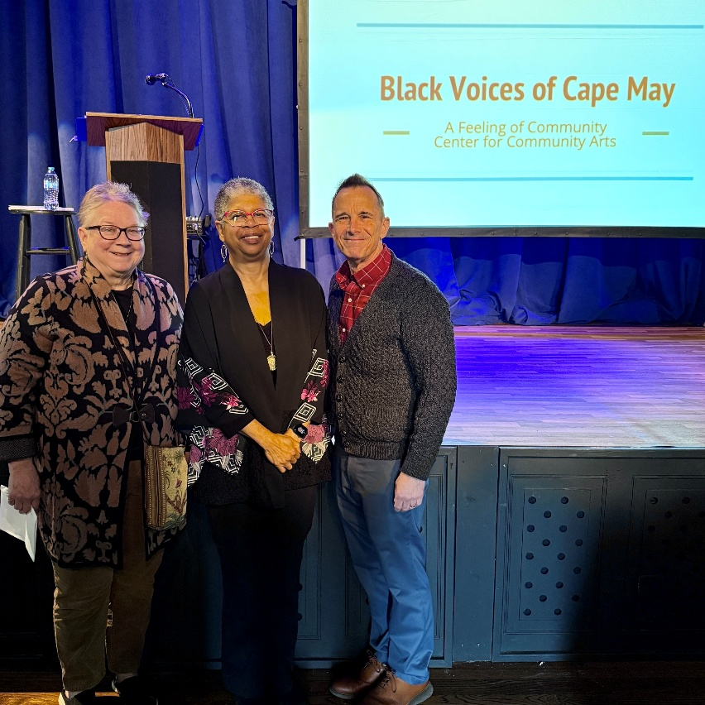

CAPE MAY - (Photo courtesy of Cape May MAC) – Cape May MAC (Museums+Arts+Culture) announces the Volunteer of the Month for July is Janis Washington White of Middle Township. She was nominated by Chief Outreach Strategist Mary Stewart . White is a member of Cape May MAC’s Diversity, Equity, Accessibility and Inclusion (DEAI) team, where she advocates for inclusive practices that honor the richness of local history and diversity. Like many Cape May MAC volunteers, she wears many hats. She also serves on the board of Cape May Stage and is a member of the Center for Community Arts (CCA) History Committee. On May 2, she juggled all three hats. As a member of the committee, she presented Cape May MAC’s fourth annual, free DEAI lecture, “Black Voices of Cape May,” at Cape May Stage, which included an American Sign Language interpreter, and donations collected for CCA. The presentation stemmed from the CCA book of the same name, a collection of history, remembrance and photographs, complemented by new details from documentation in the 2024 amendment to Cape May’s Historic Register designation. “Janis brought a very personal perspective to her presentation, as she was born and raised in West Cape May and is a fifth-generation member of its Black community,” said Stewart. “Her knowledge runs deep. In the book, she identified many of the individuals in the photographs. She also identified and located buildings, some of which are still standing, and some of which were lost to Urban Renewal in the 1960s. She shared these insights in her presentation to a very enthusiastic audience. It was a very personal journey through an often-overlooked piece of local history — the contribution of Cape May’s Black residents to its rich history. Cape May MAC is so grateful to her for sharing her expertise as an educator and deep knowledge as a long-time resident.” Shown here, from left, Cape May MAC Chief Outreach Strategist Mary Stewart, Janis Washington White and Cape May MAC Director and CEO Jody Alessandrine. For information about volunteer opportunities at Cape May MAC, contact Volunteer Coordinator Maria Amin at 609-224-6029 or mamin@capemaymac.org. Cape May MAC is a multifaceted not-for-profit organization committed to promoting the preservation, interpretation and cultural enrichment of the Cape May region for its residents and visitors. Cape May MAC membership is open to all. For information about the year-round schedule of tours, festivals and events, visit capemaymac.org.
###

